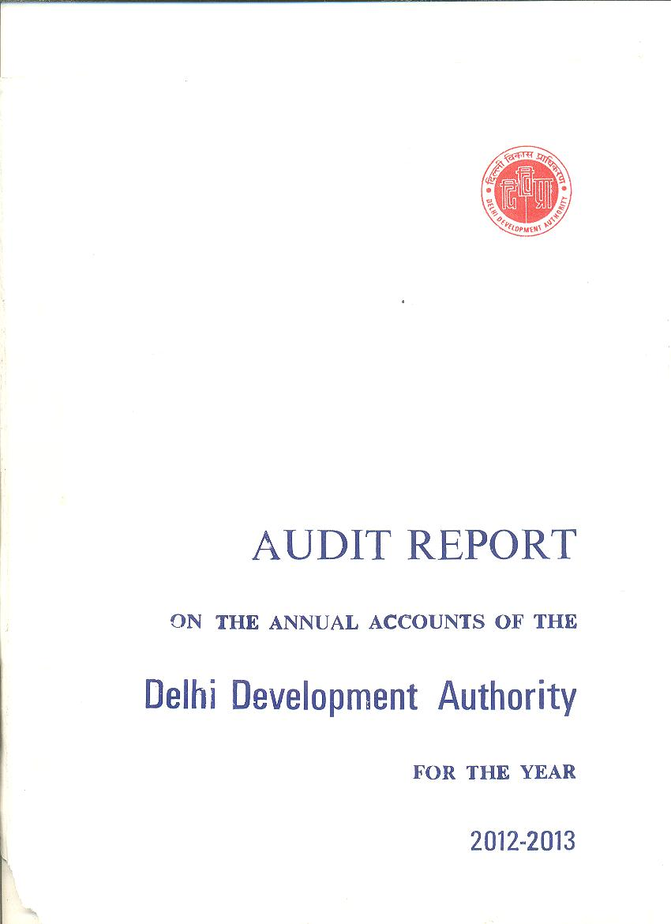
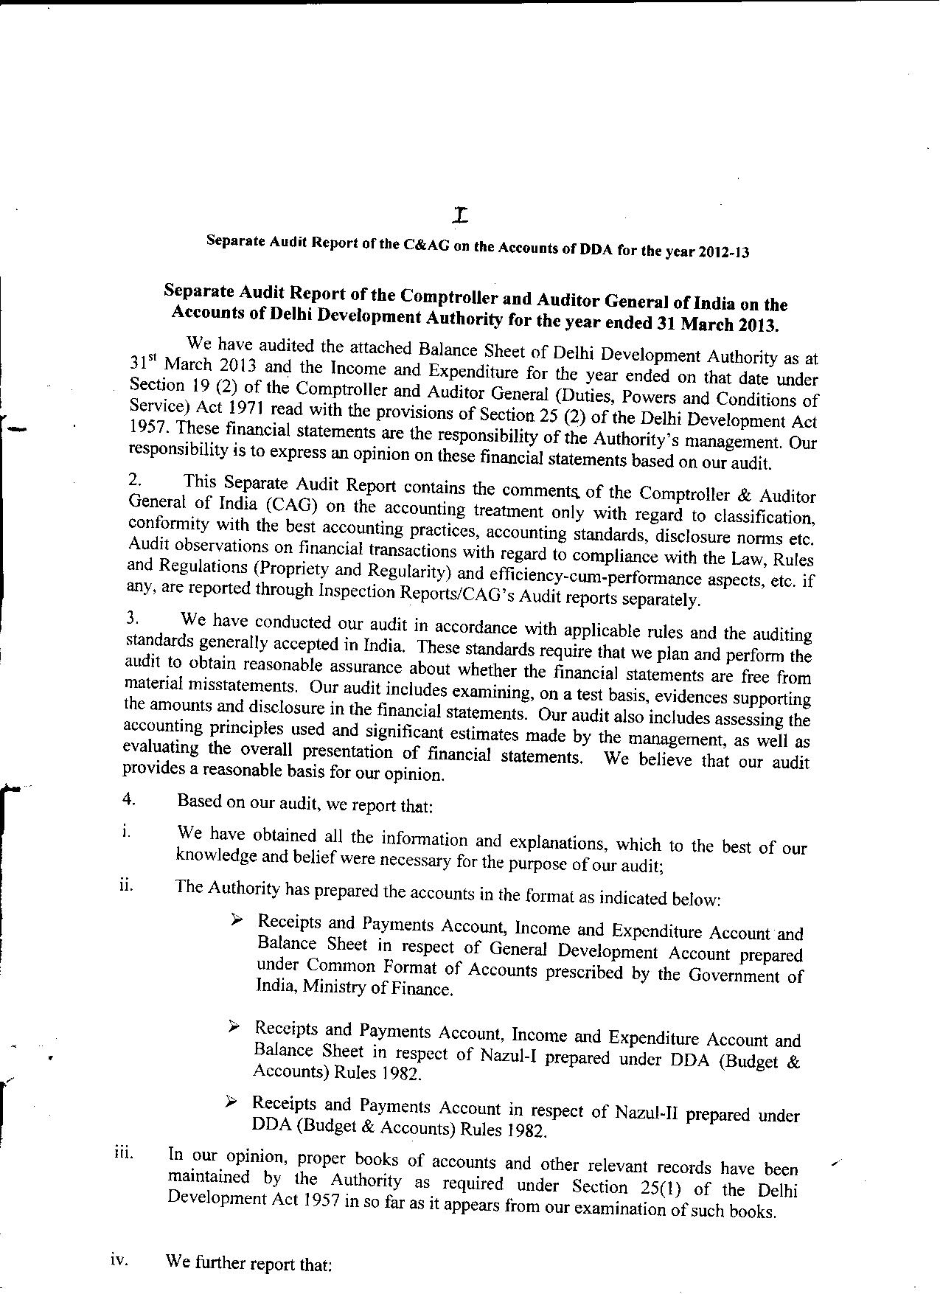
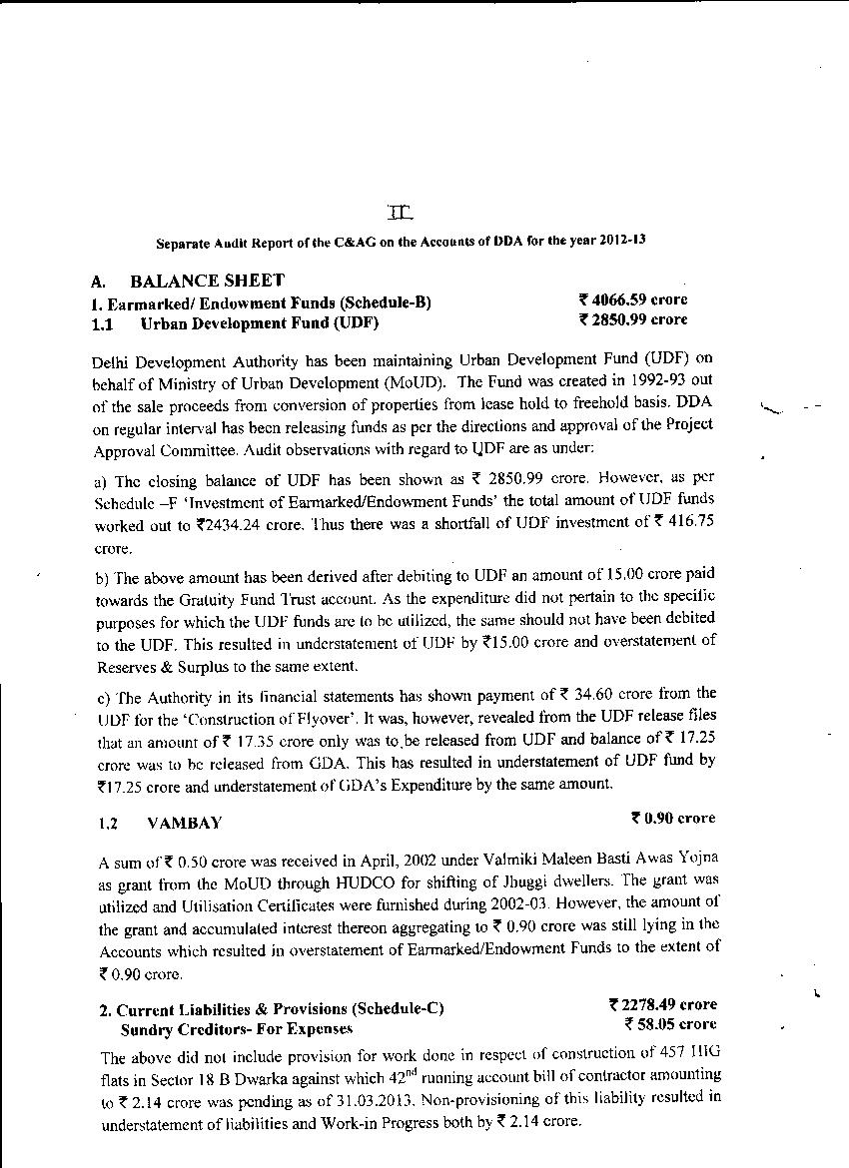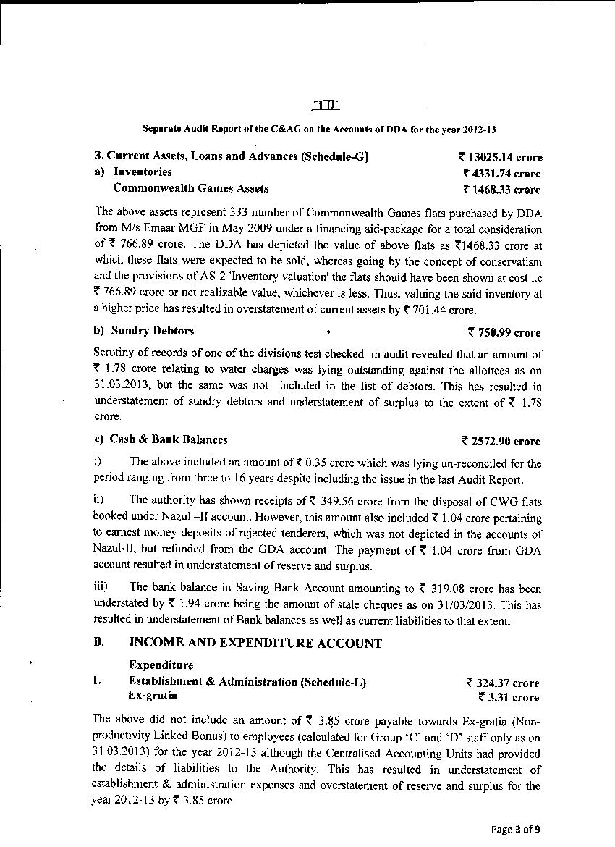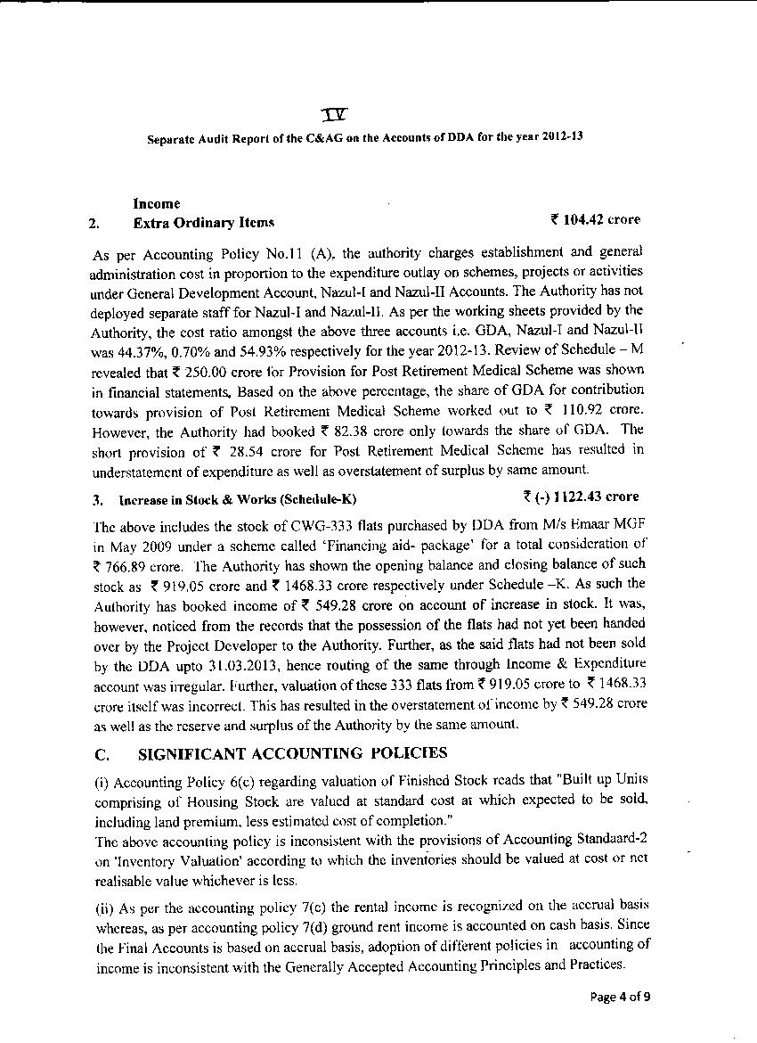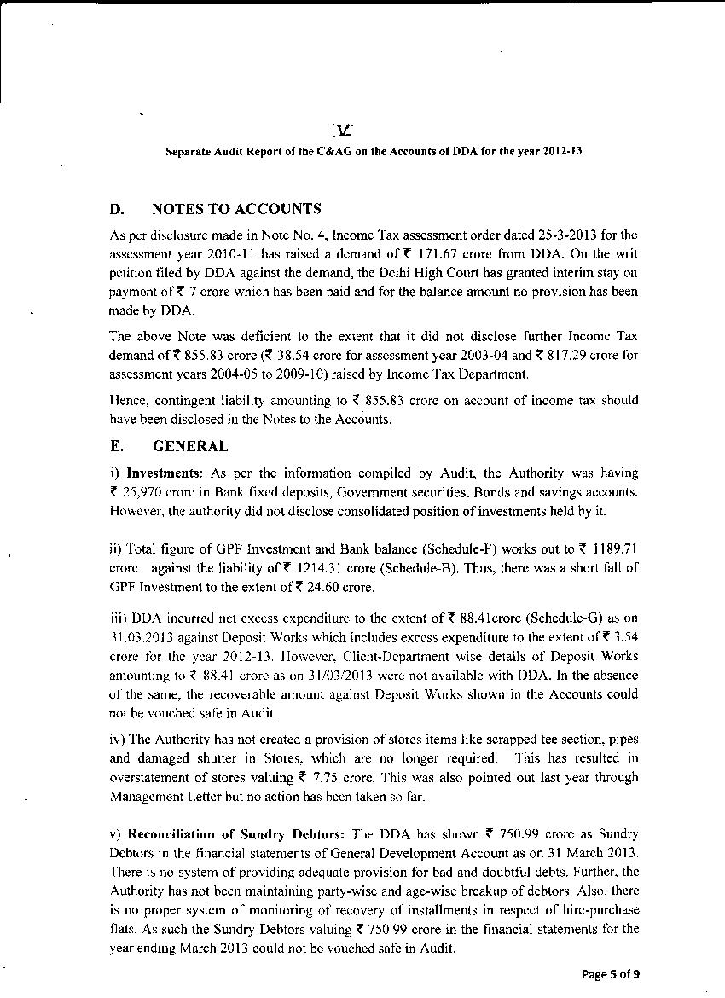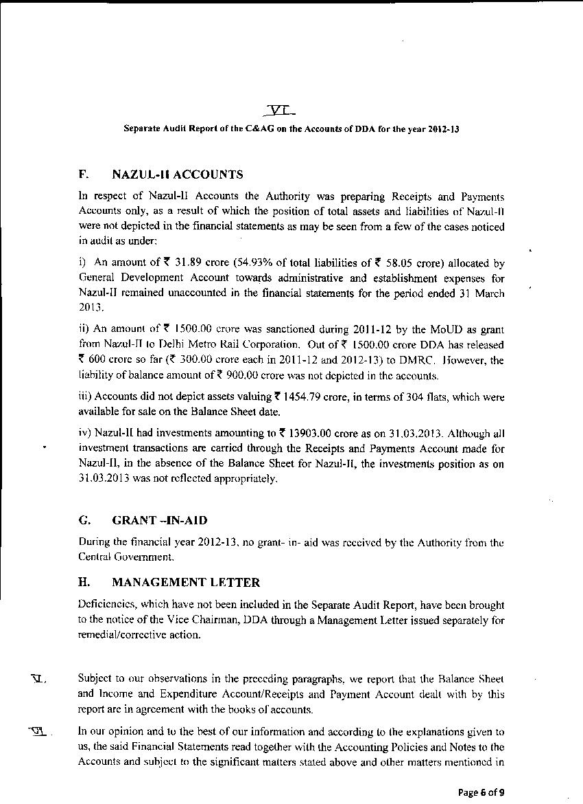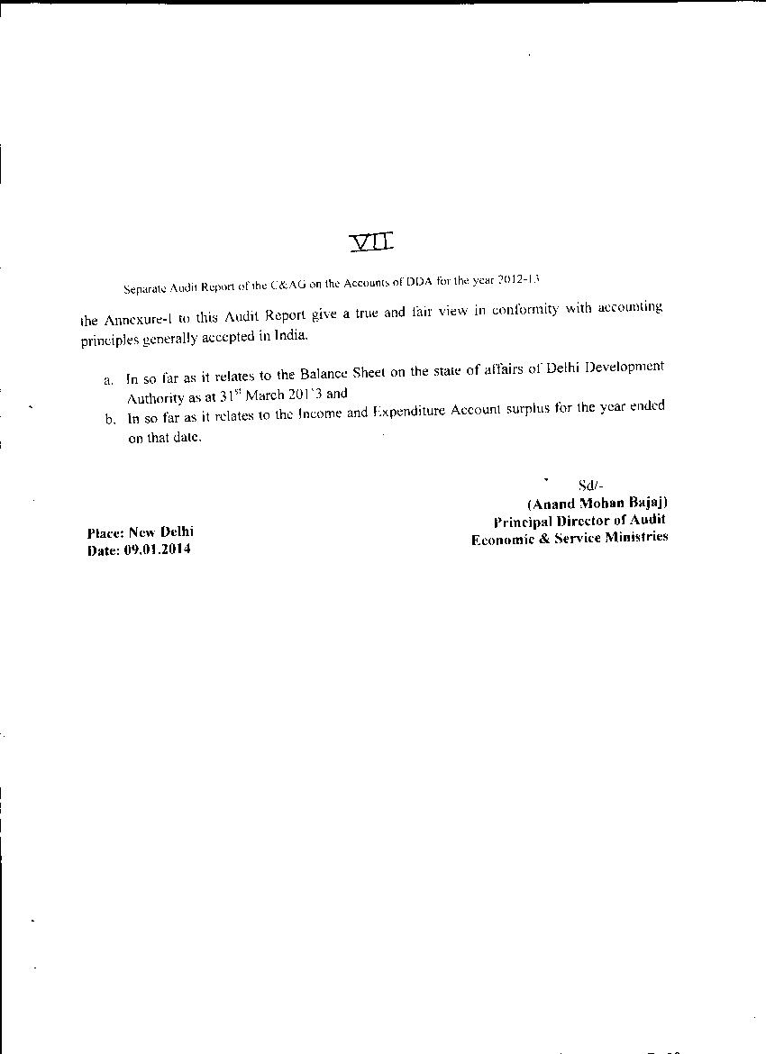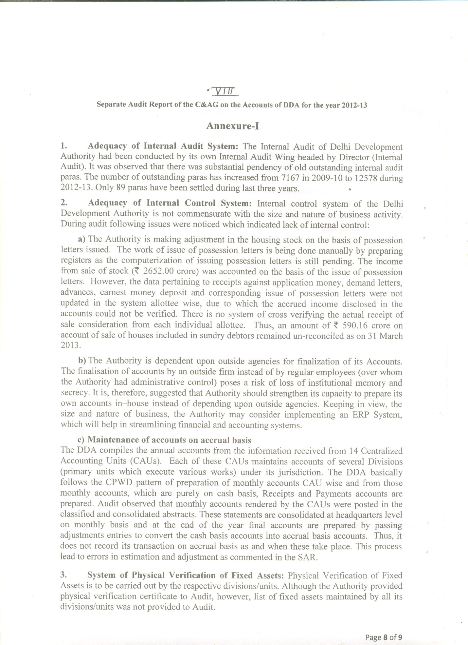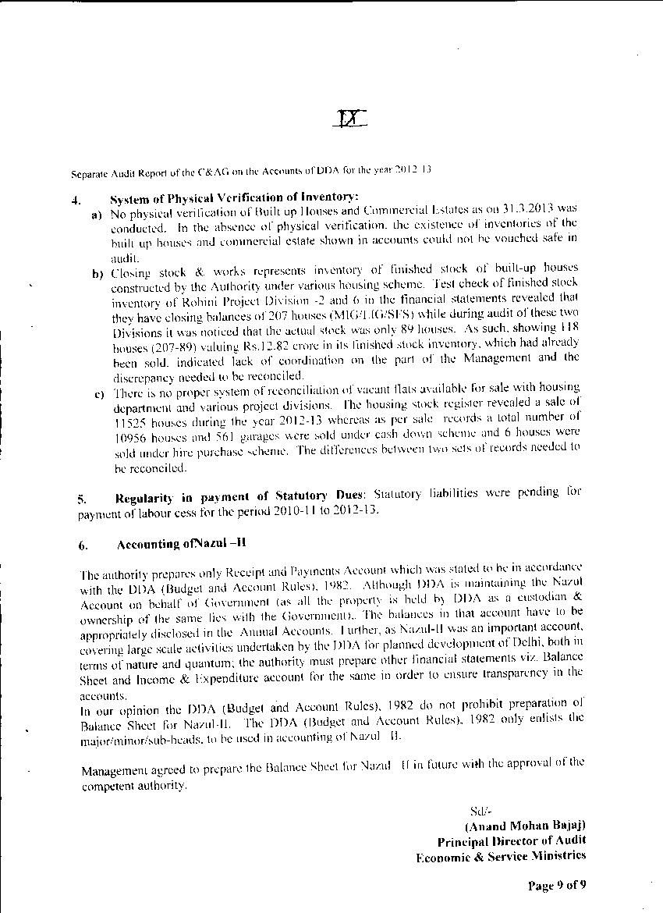
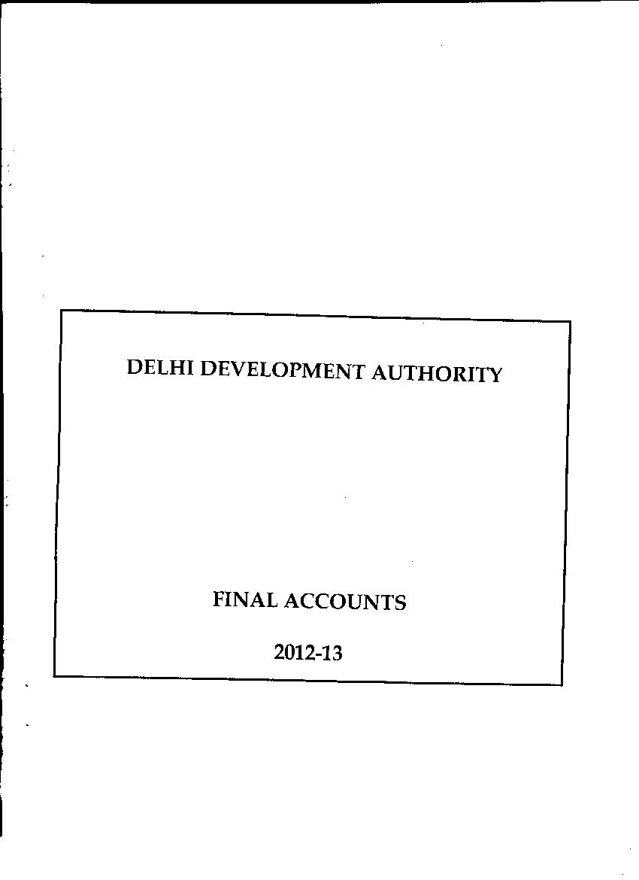
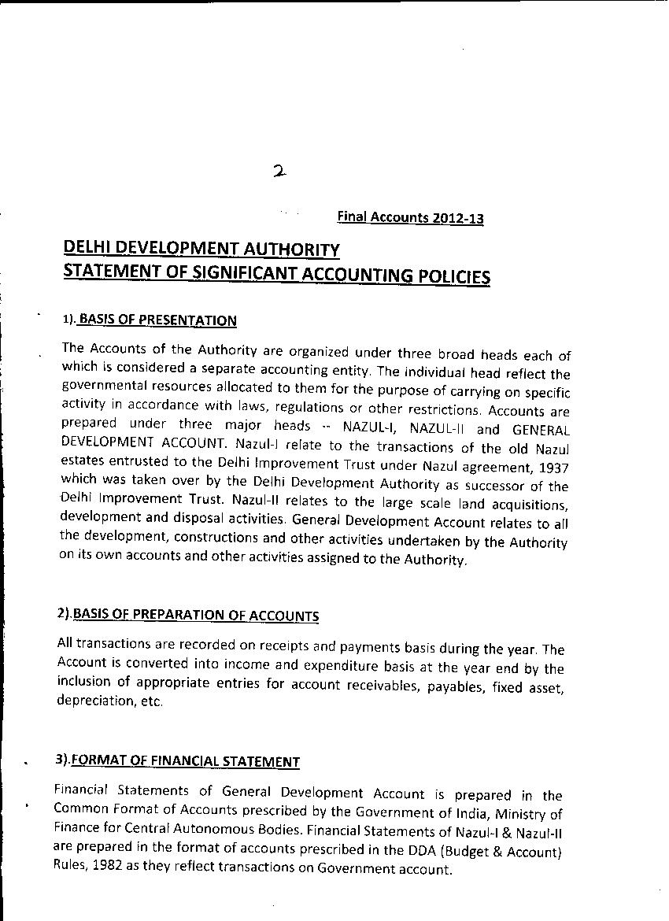
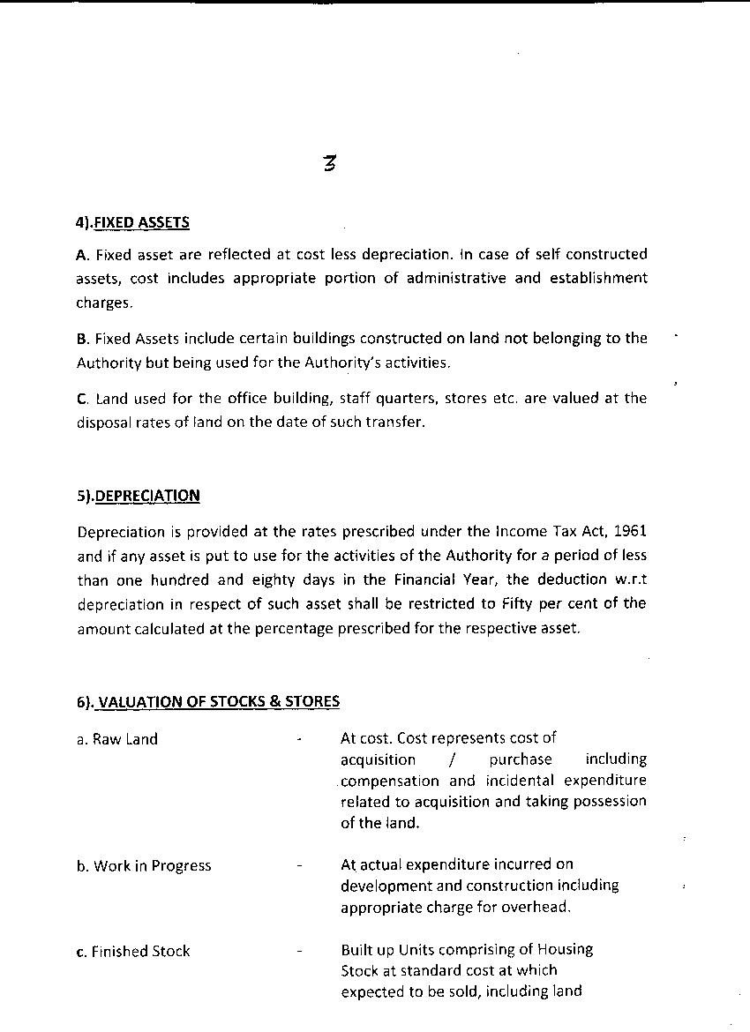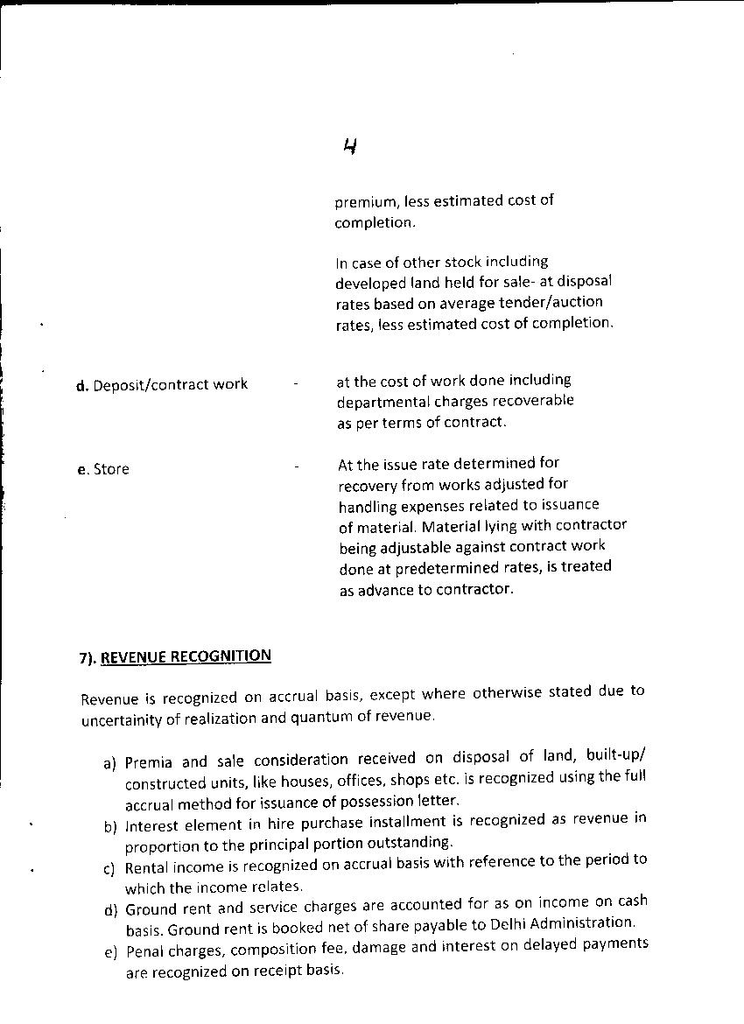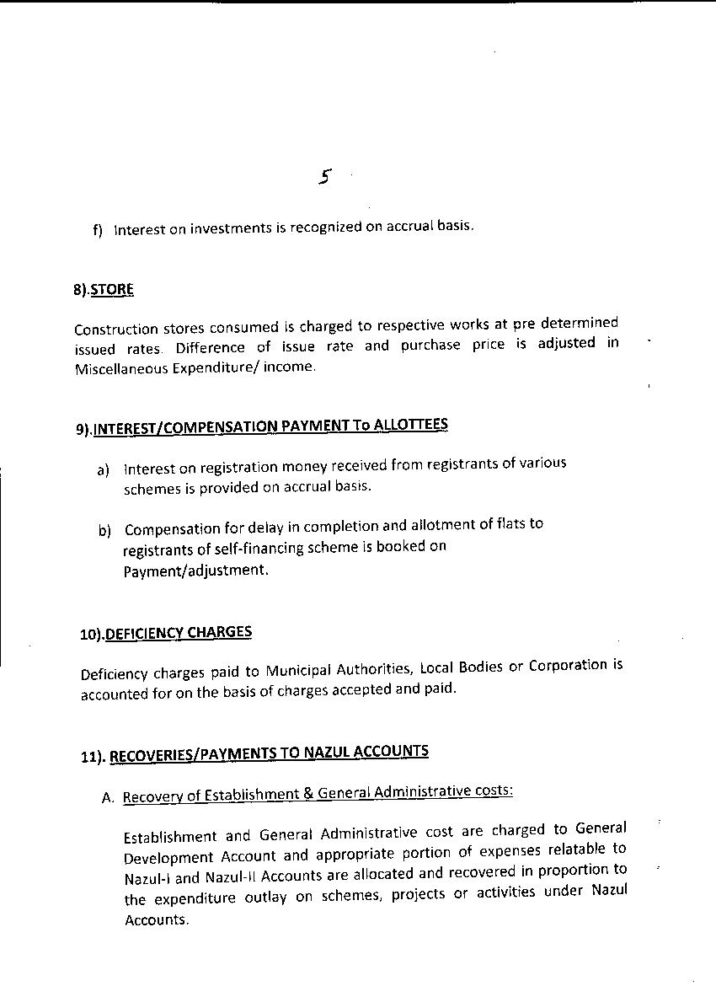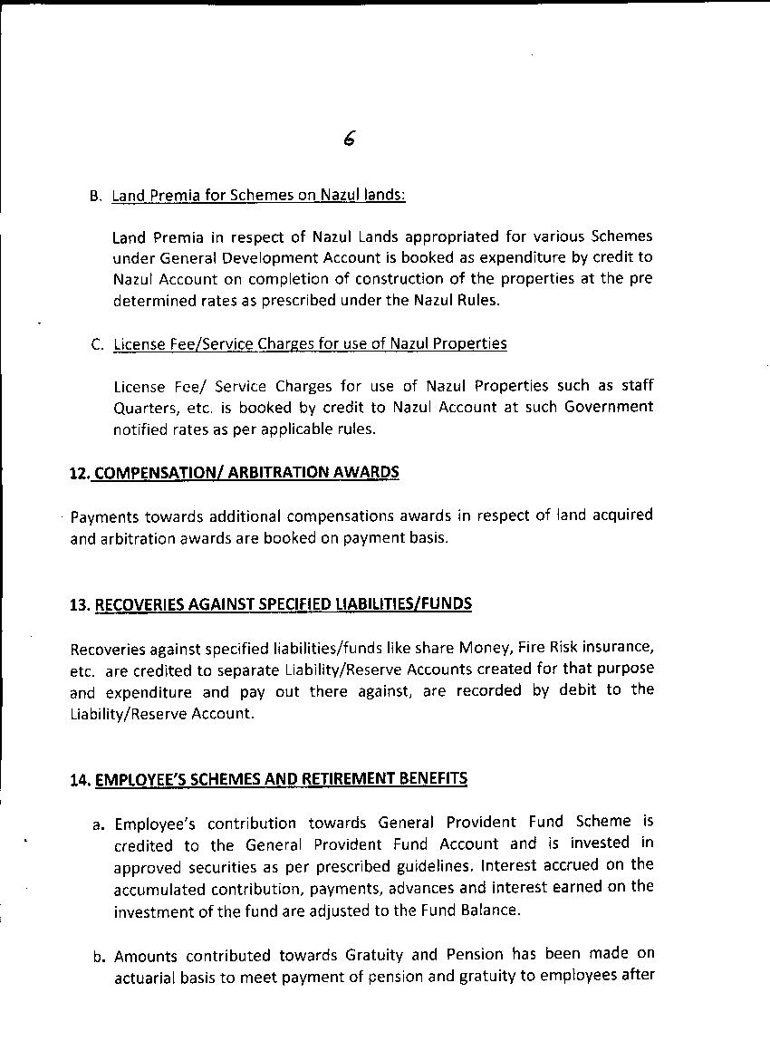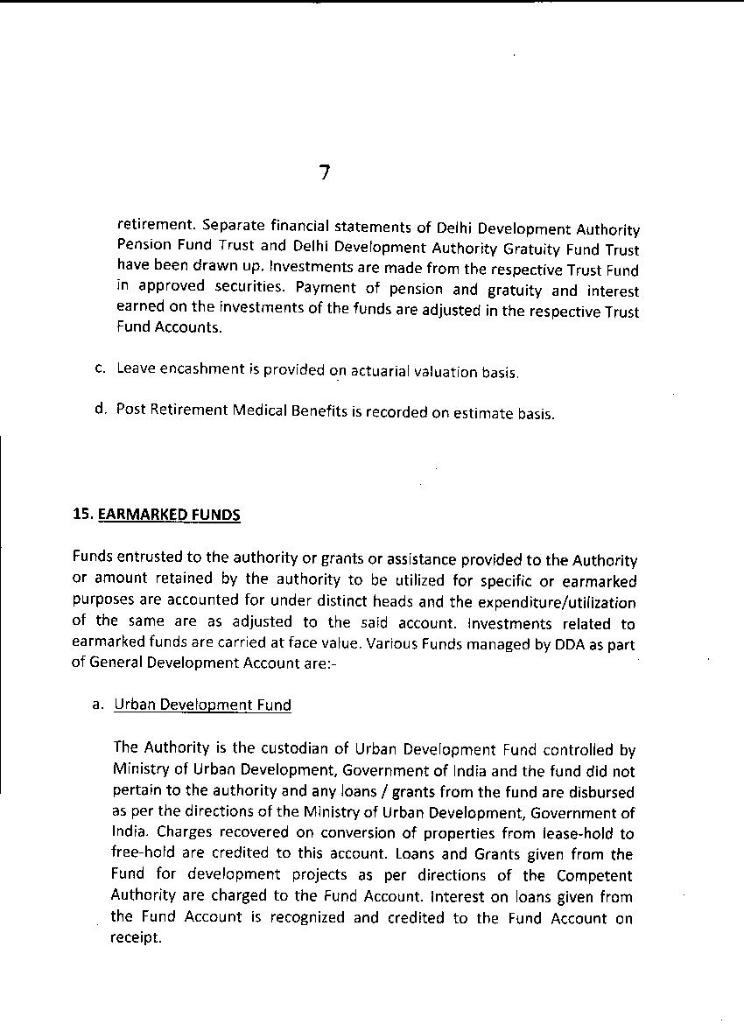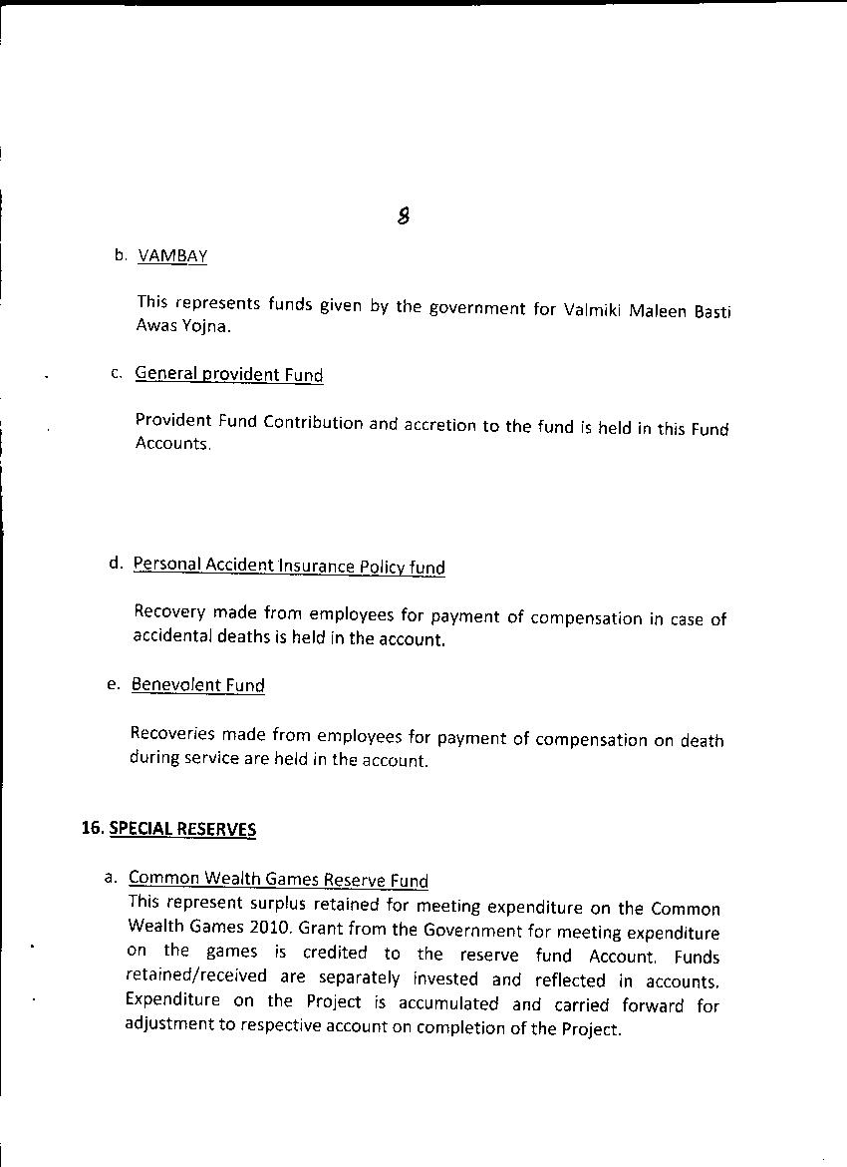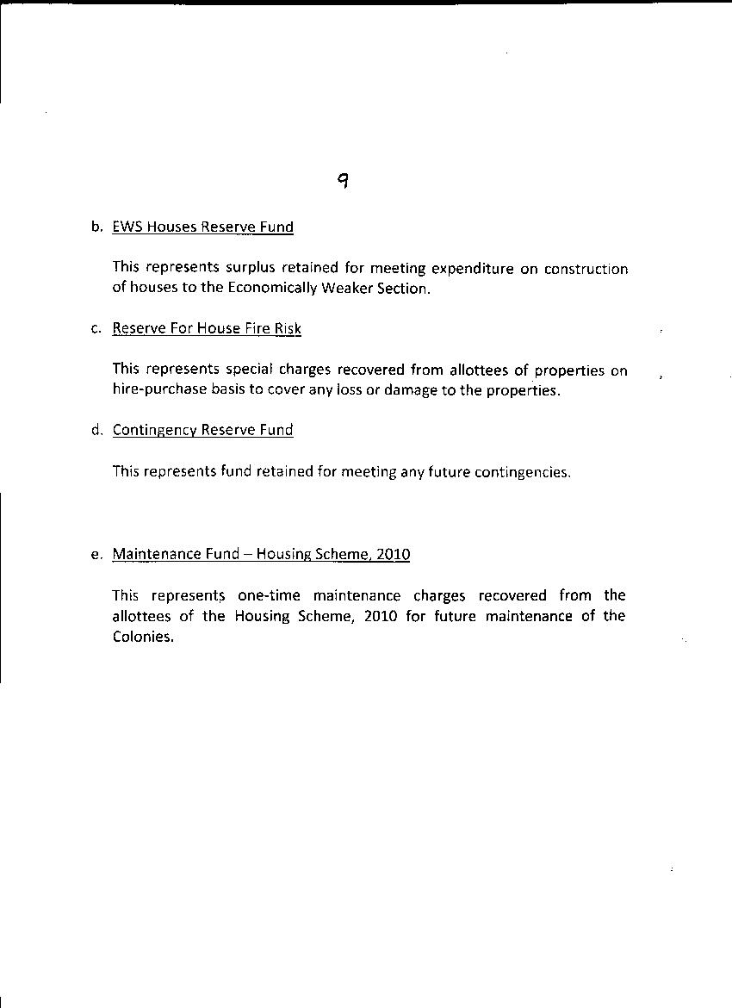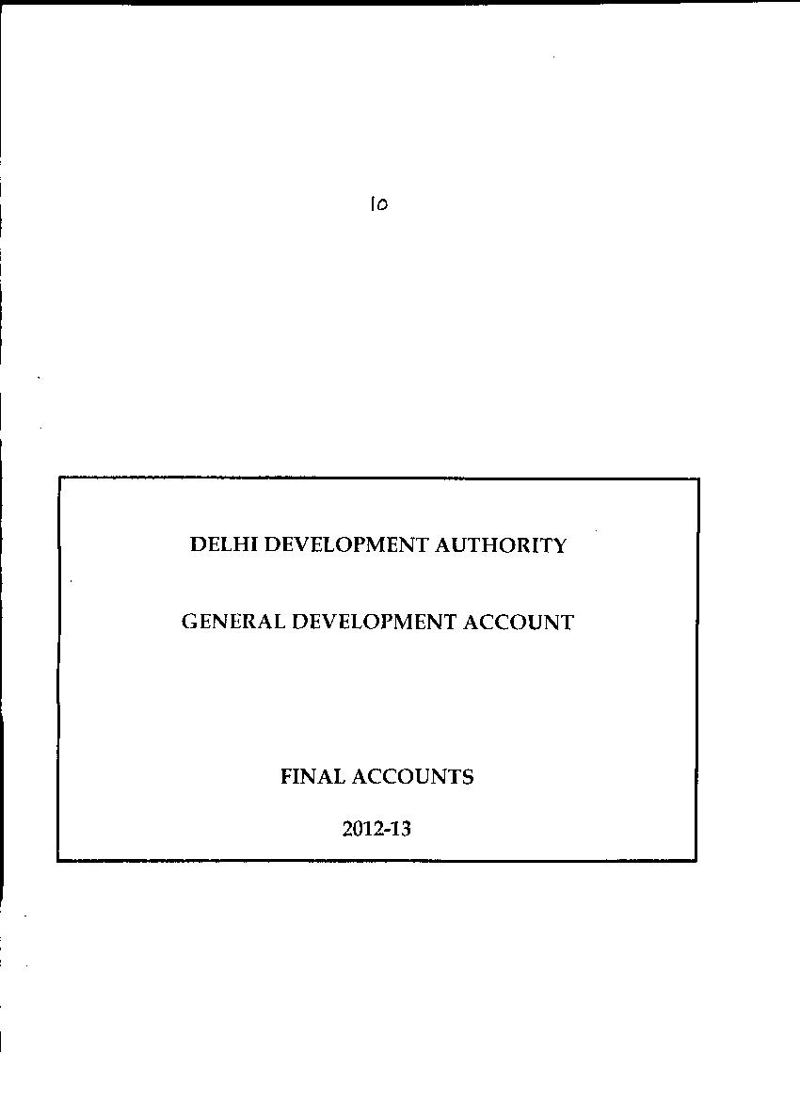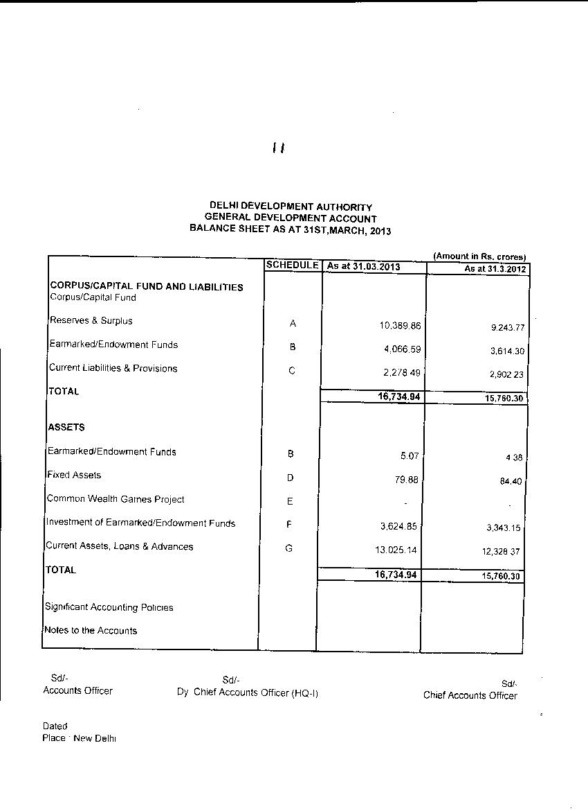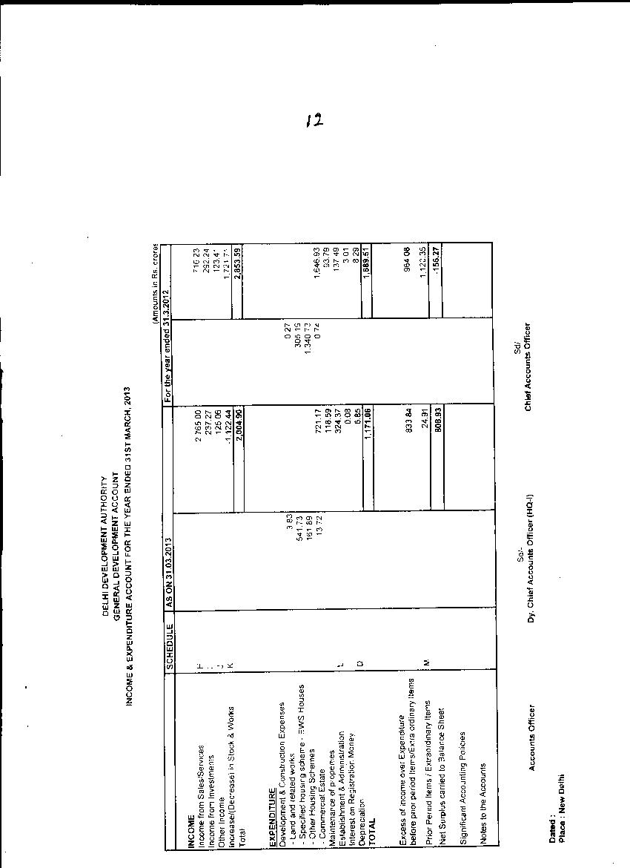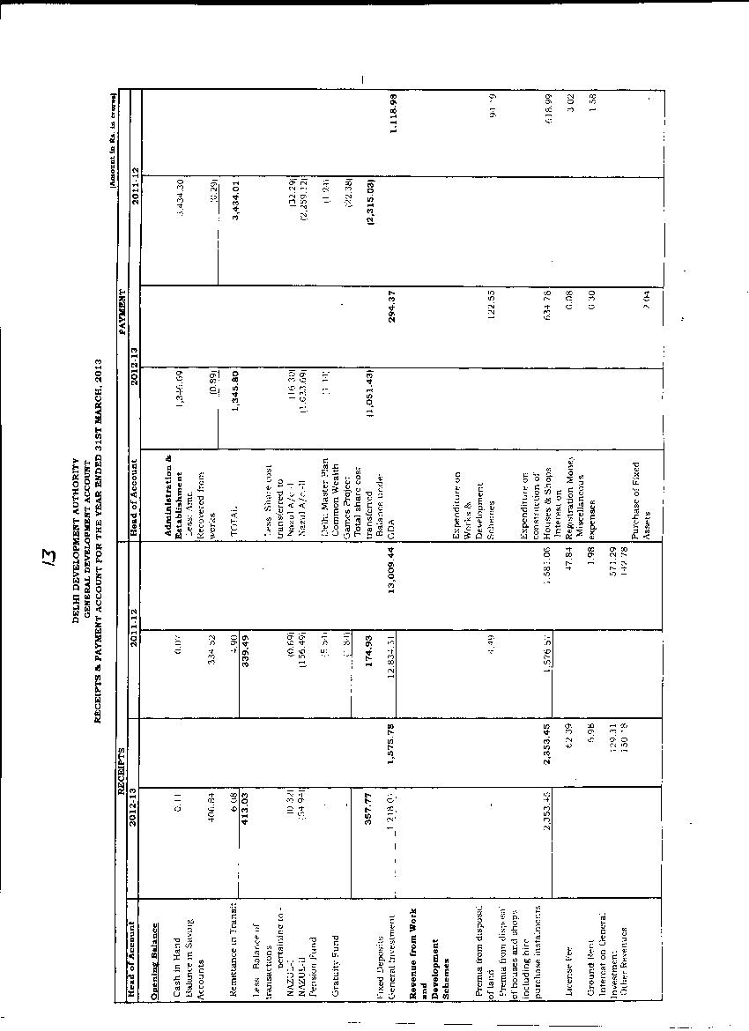
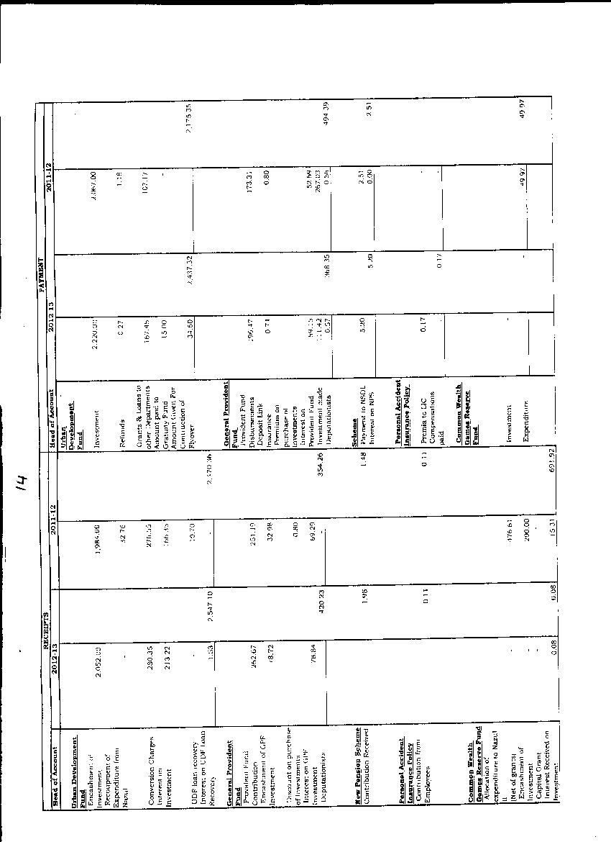
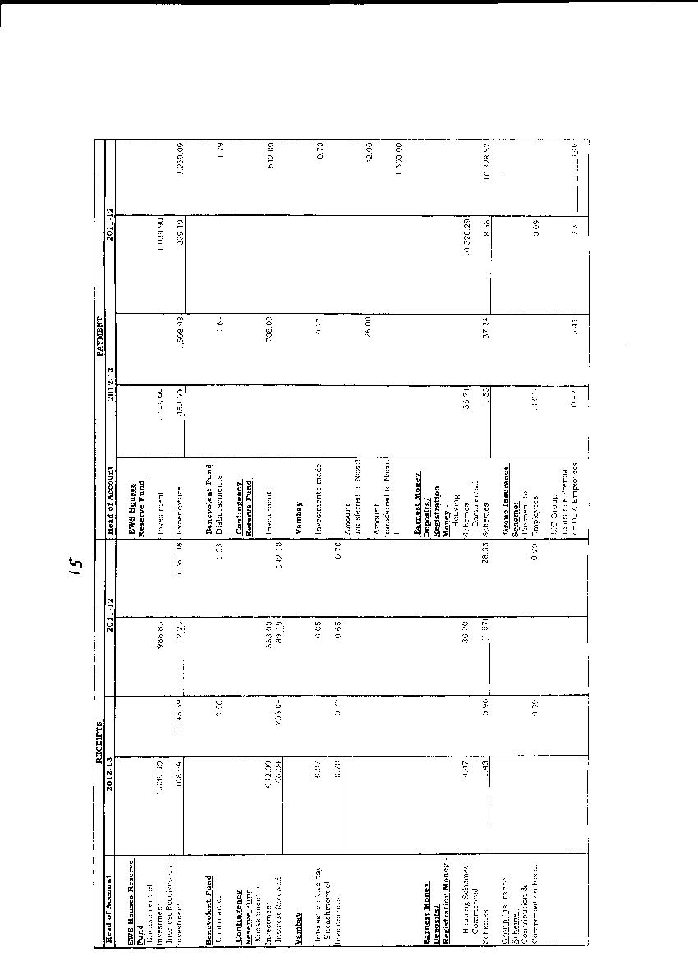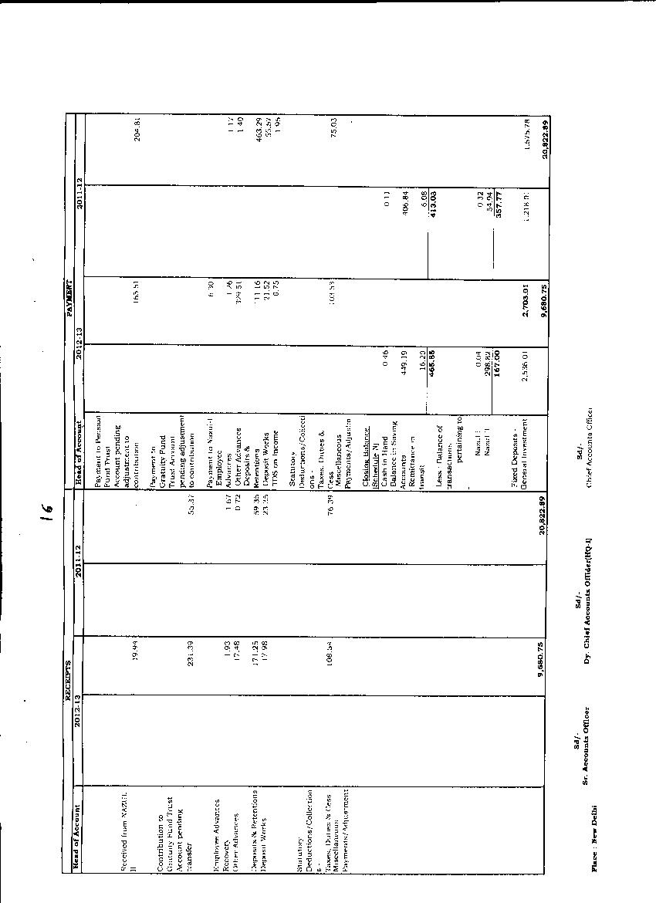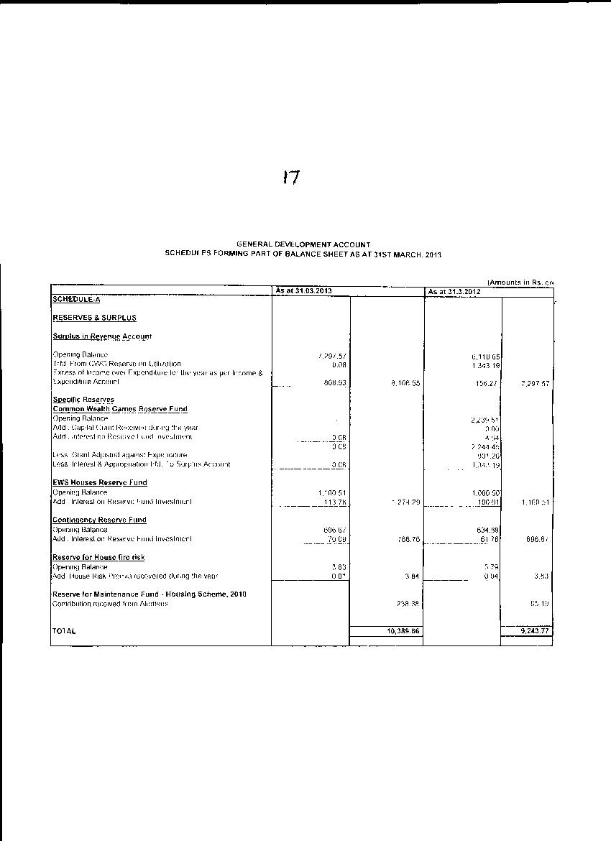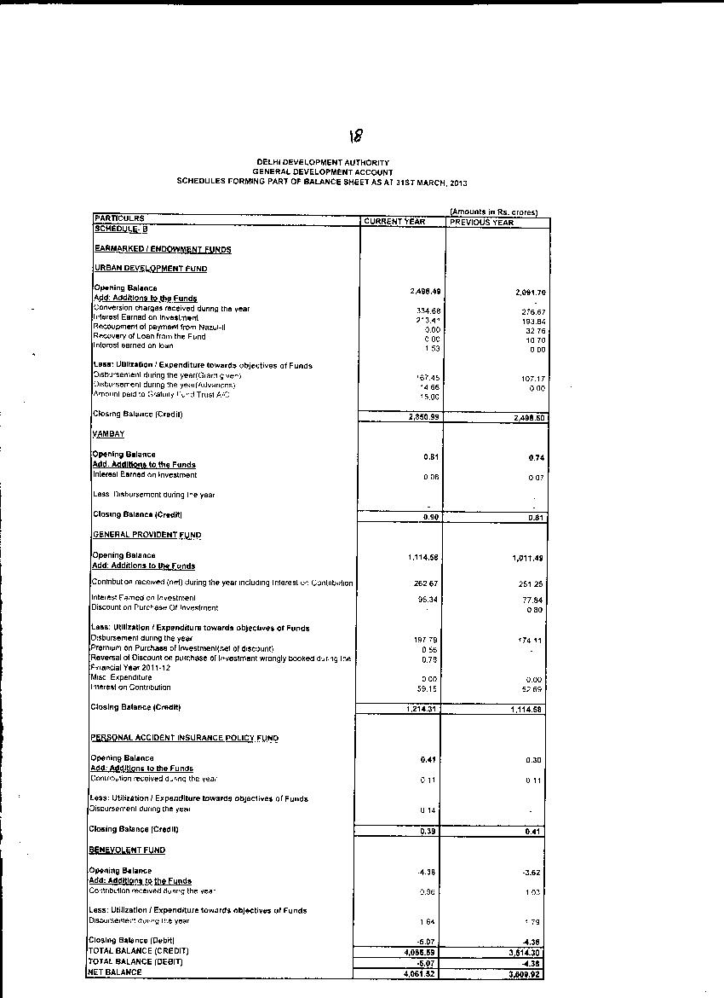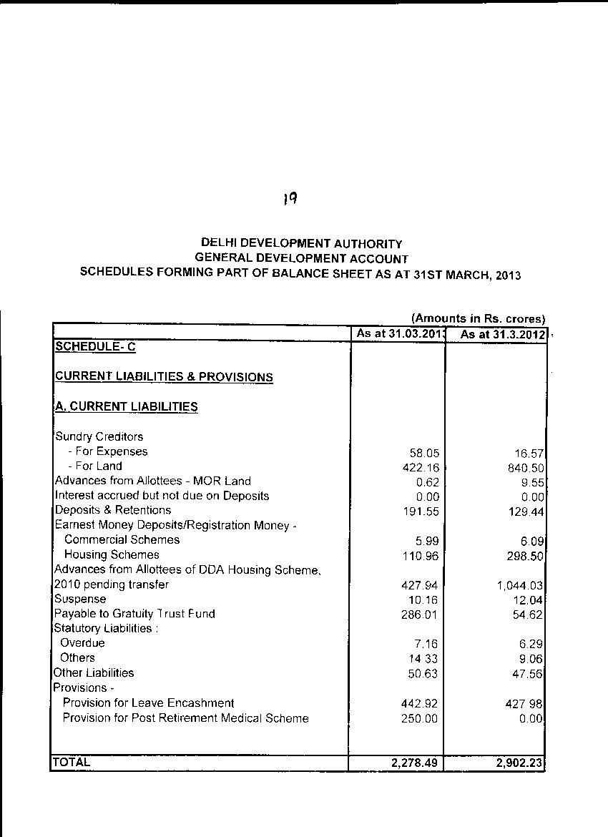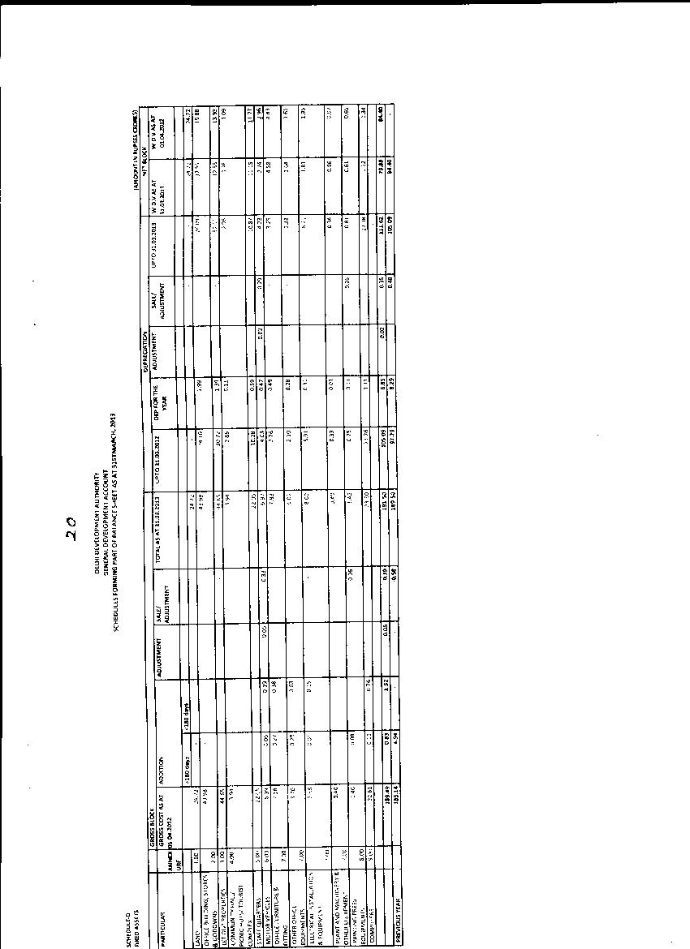
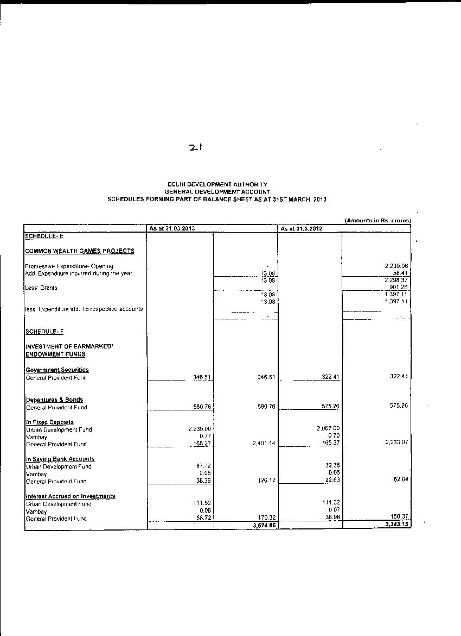
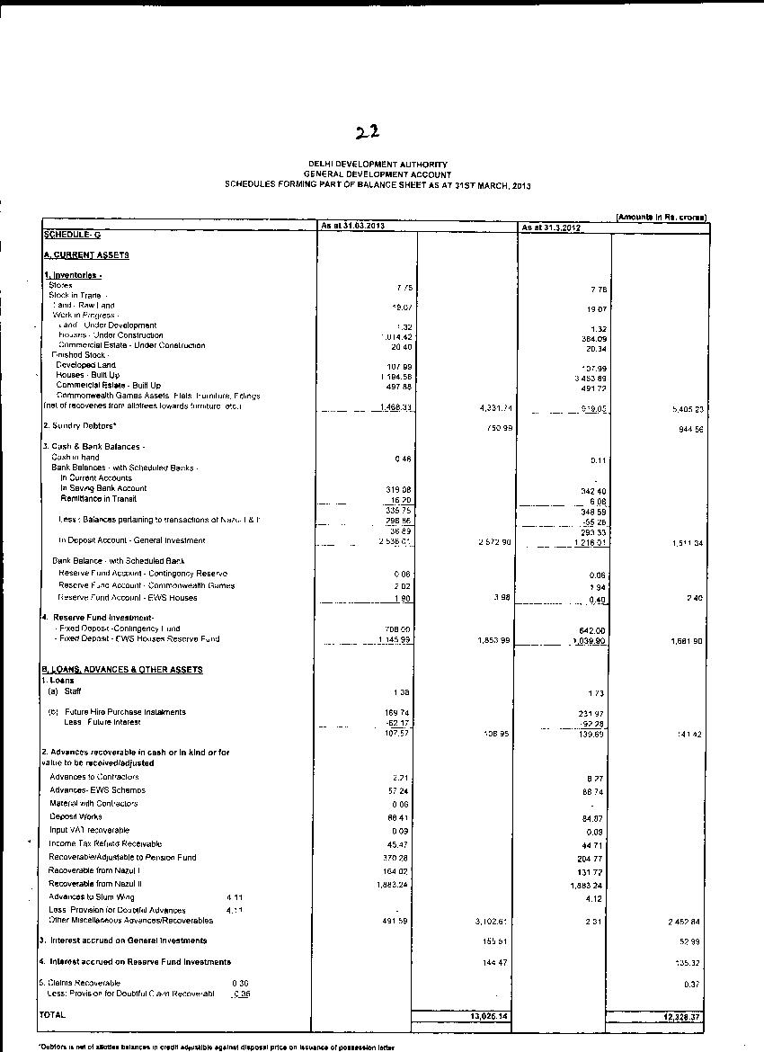
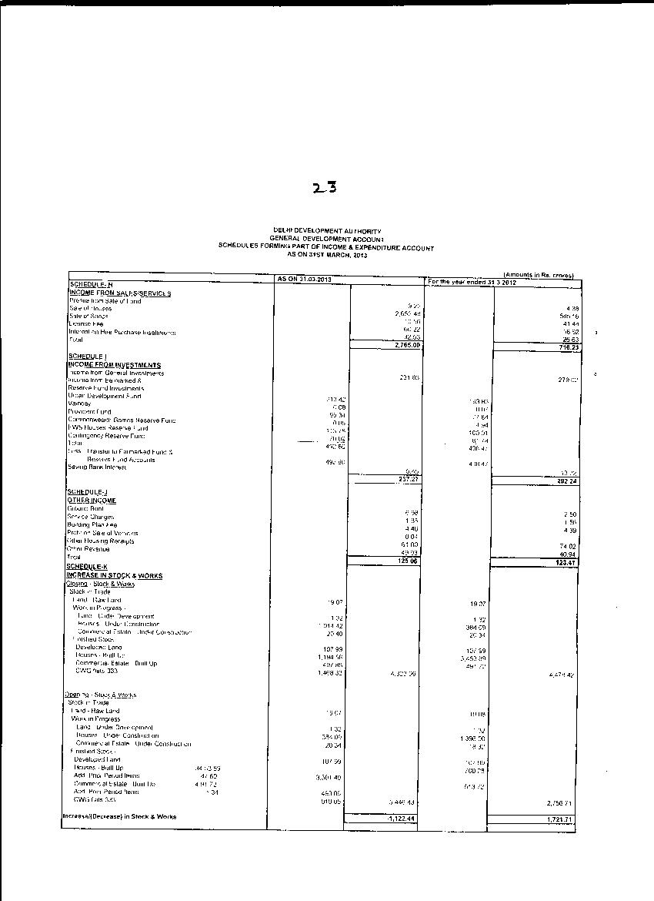
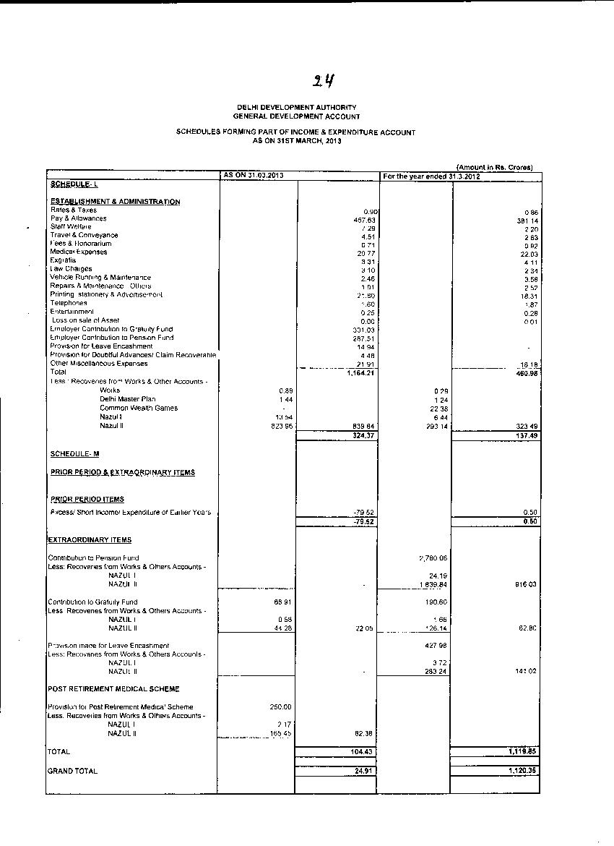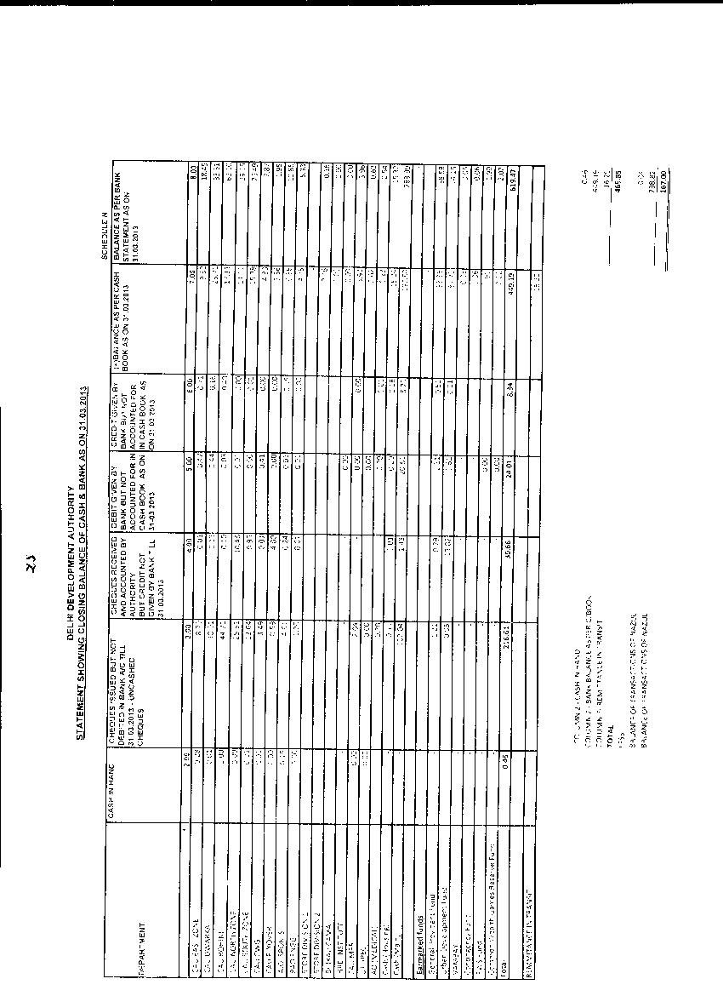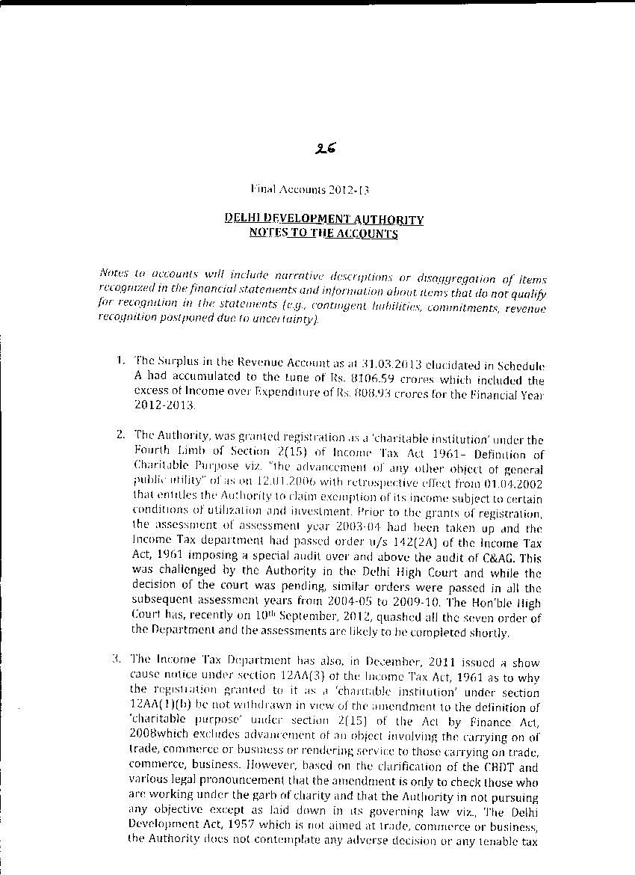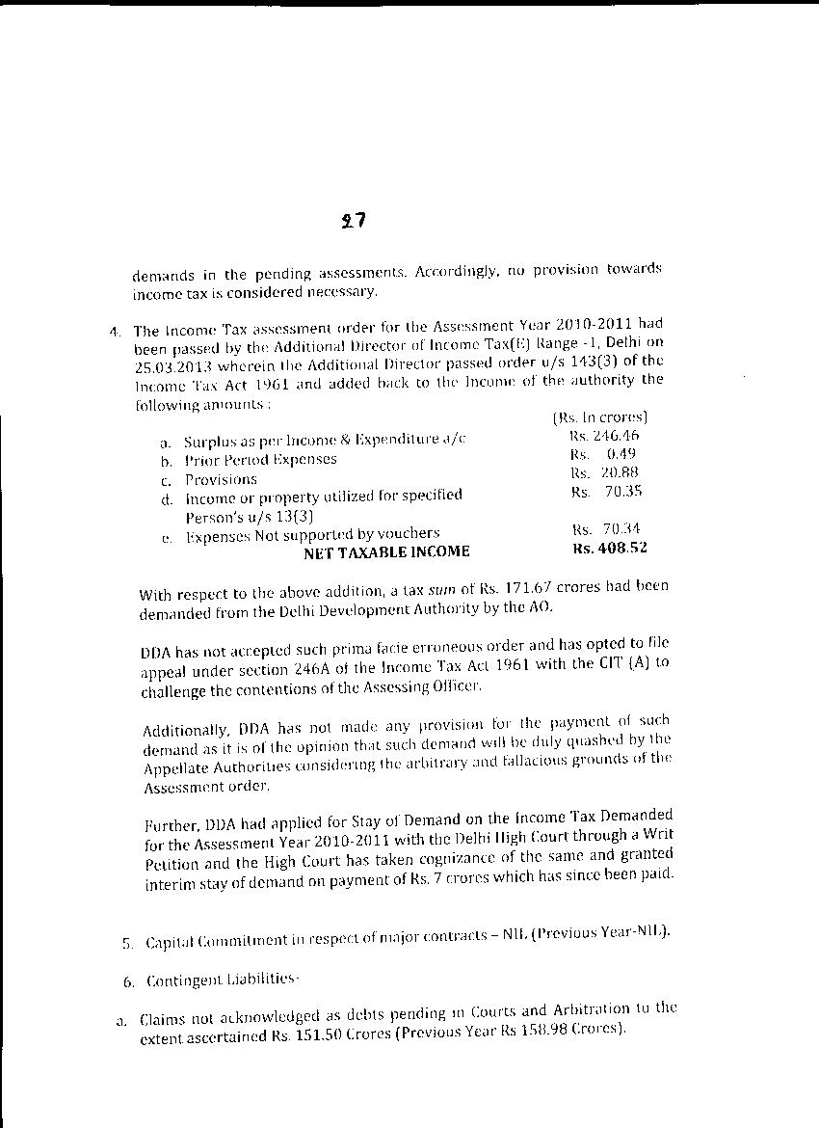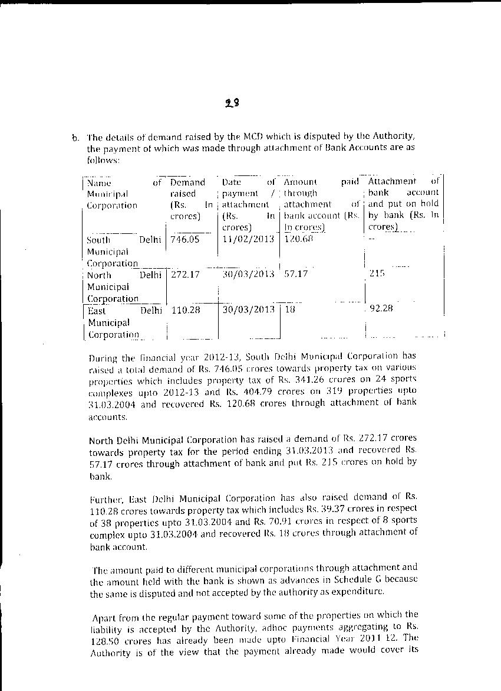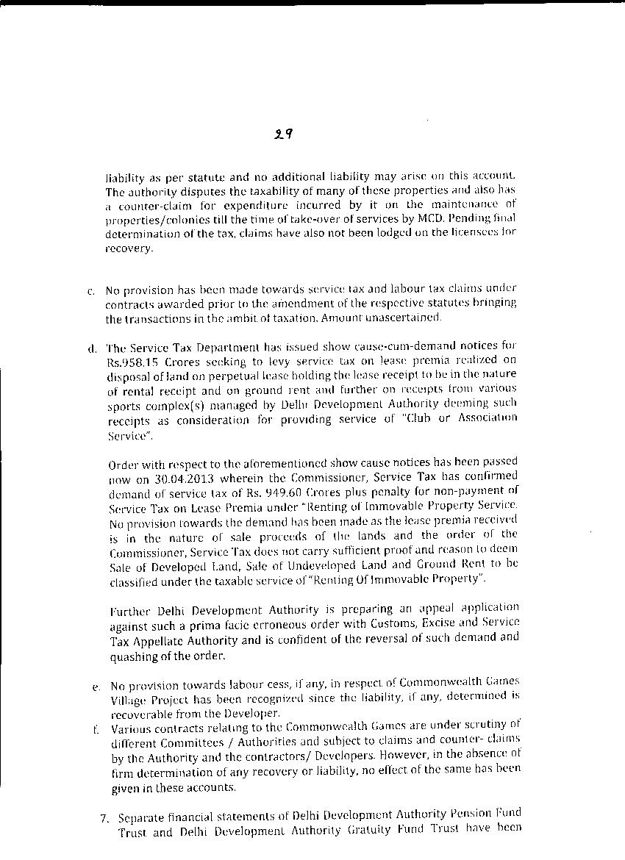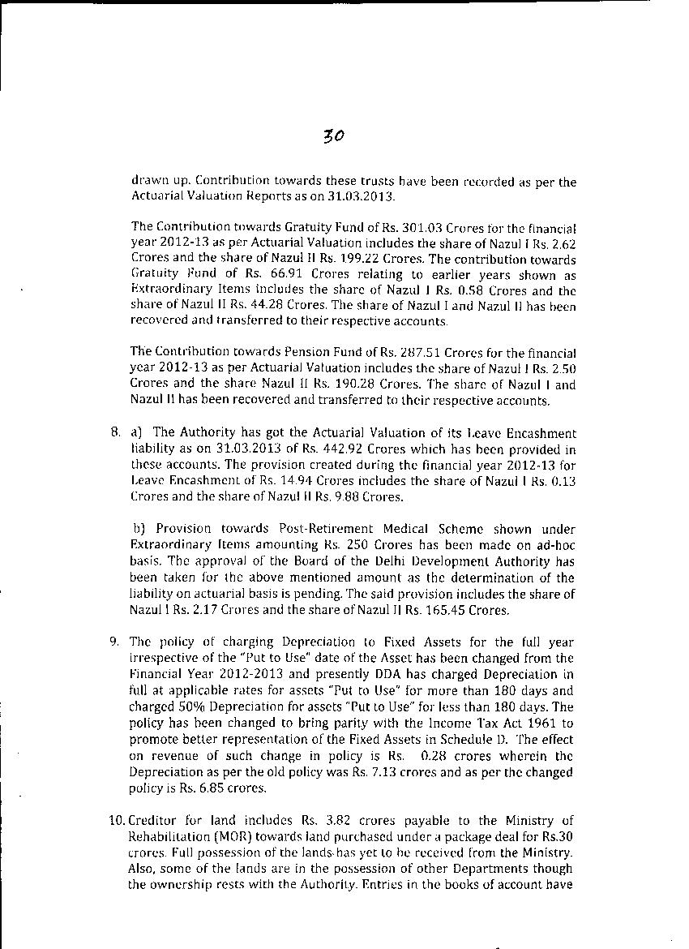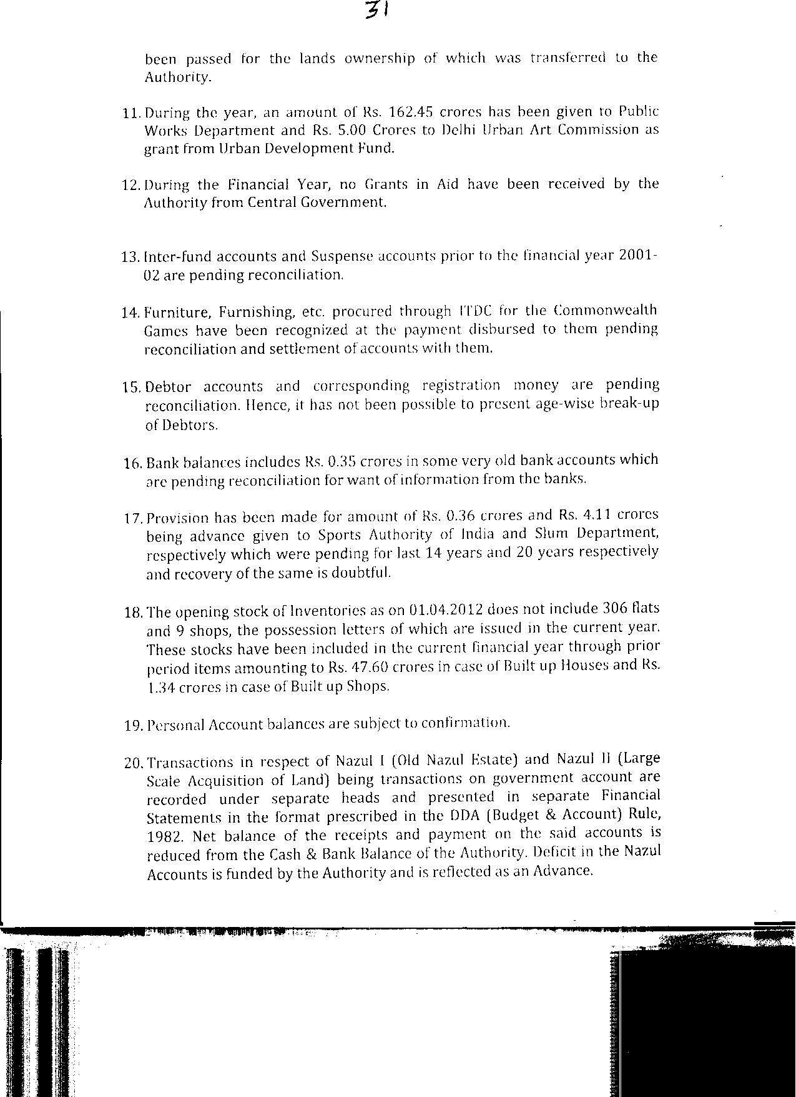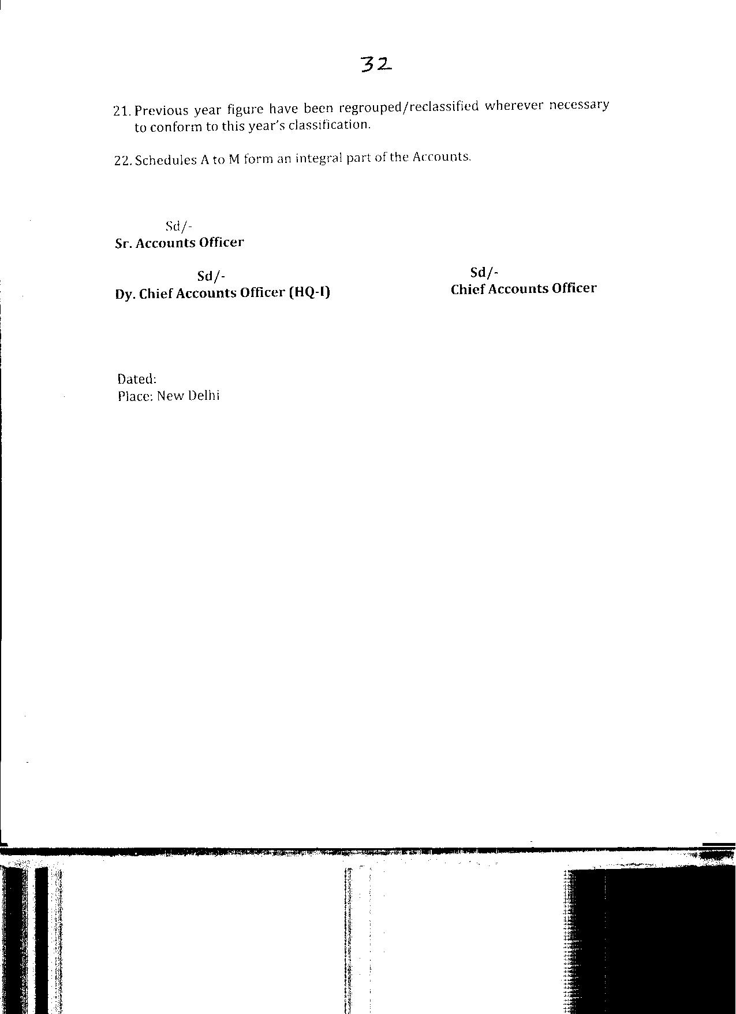

33

DELHI DEVELOPMENT AUTHORITY

FINAL ACCOUNTS

NAZUL ACCOUNT I

2012-13

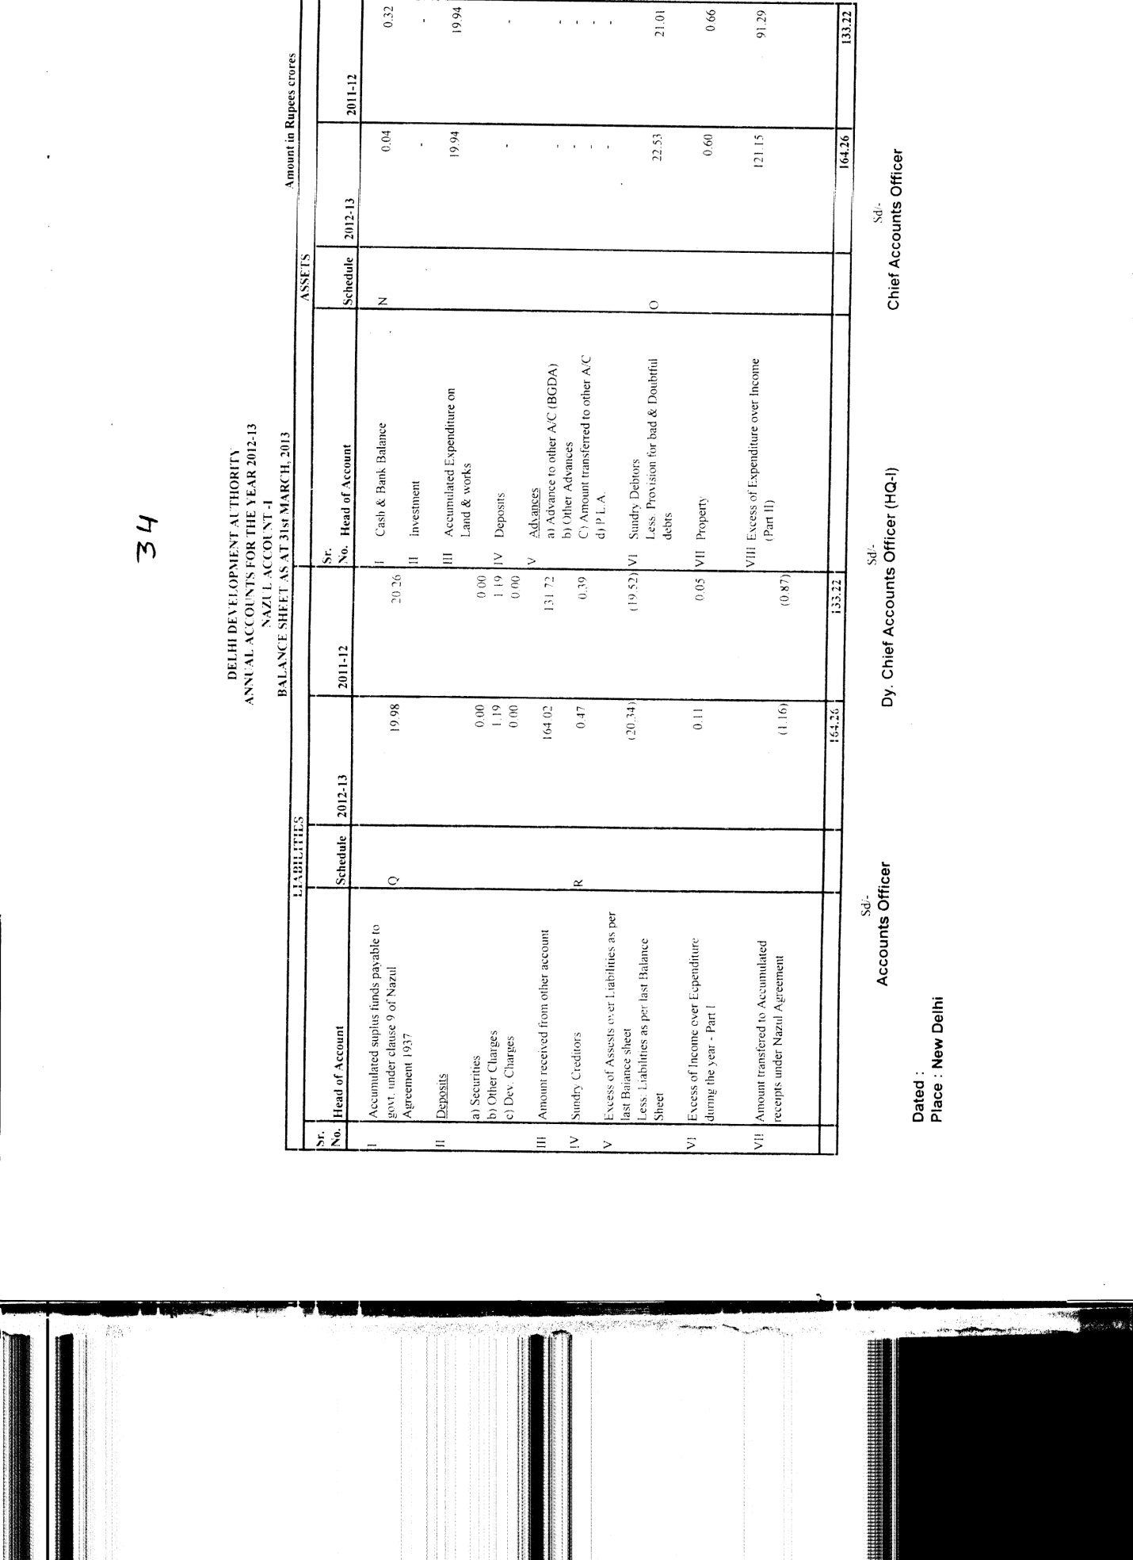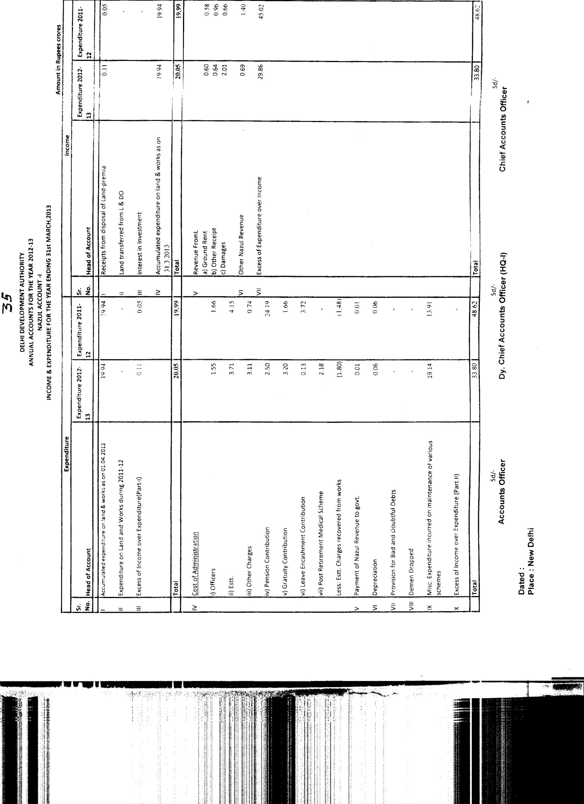
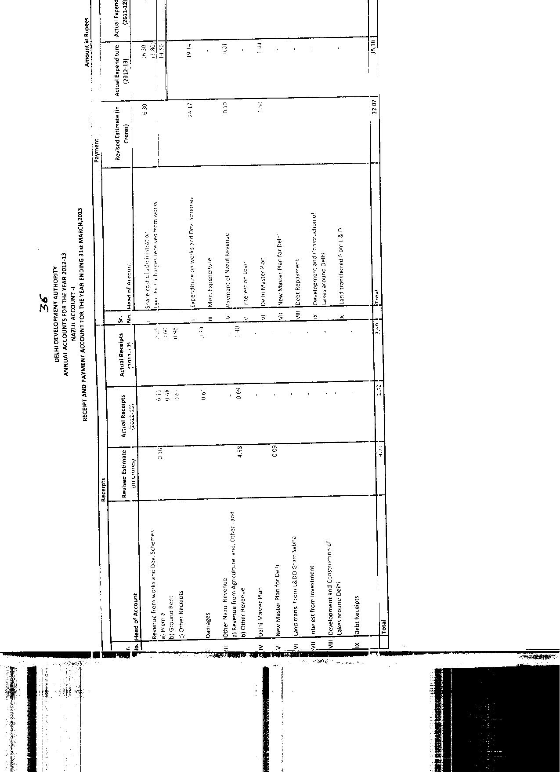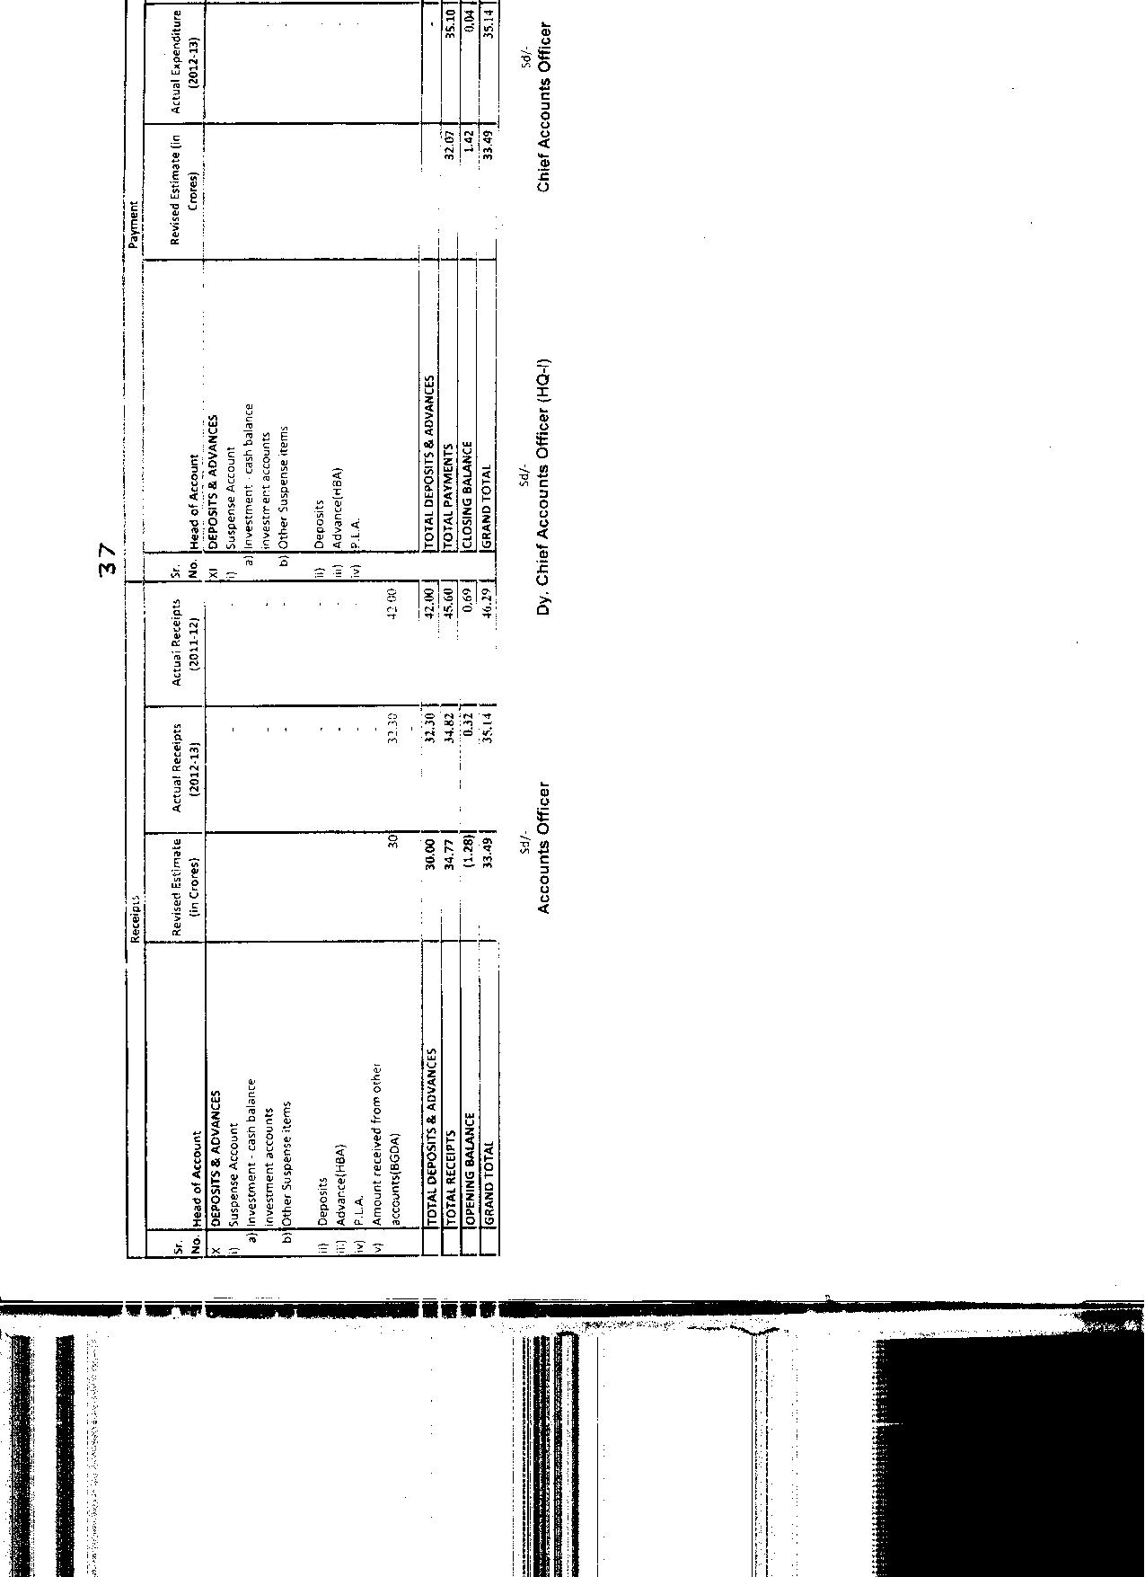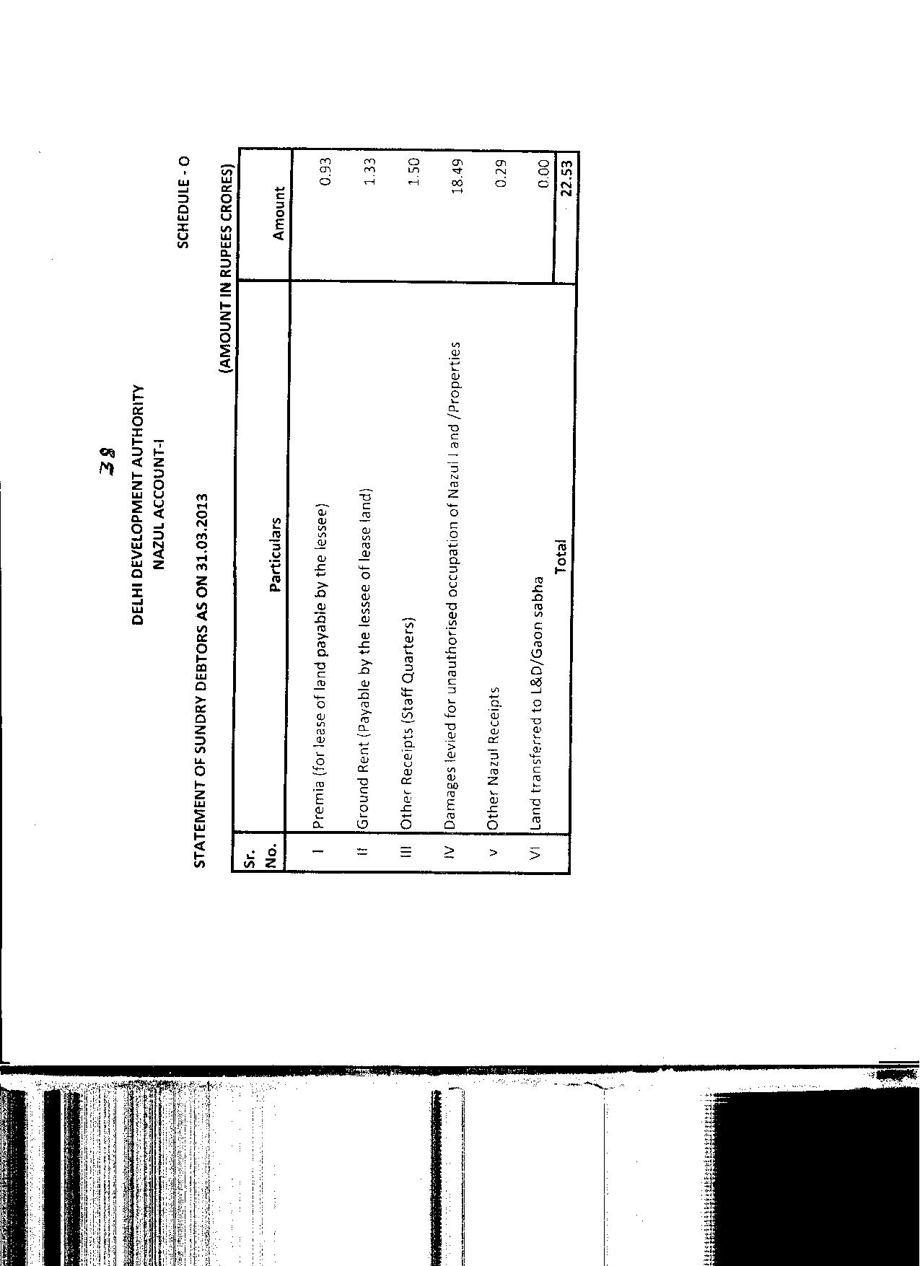
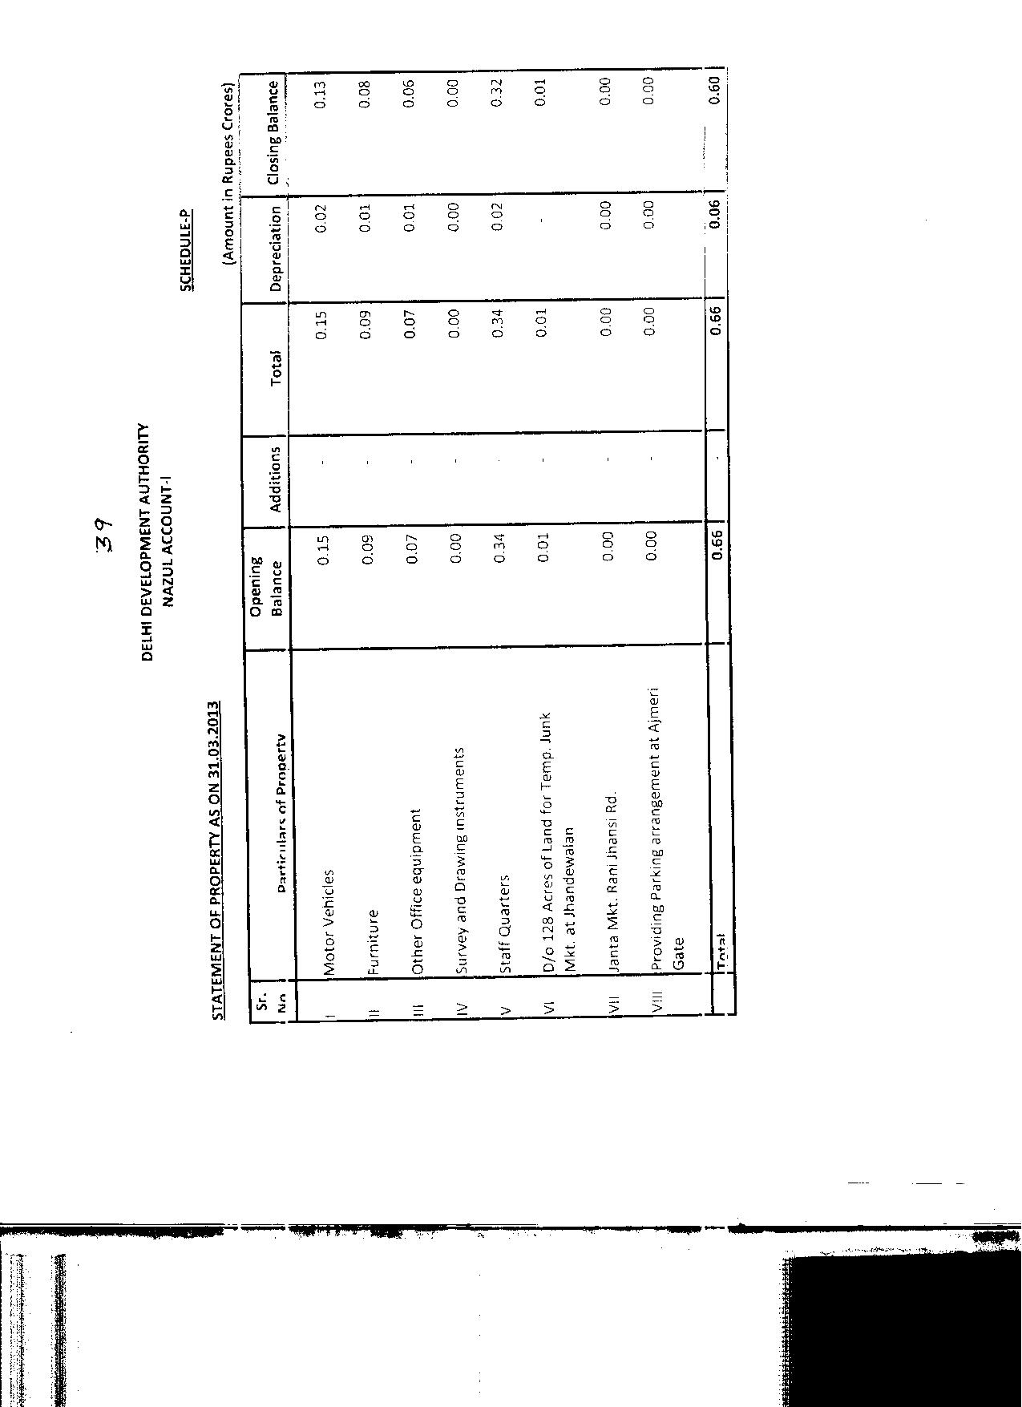
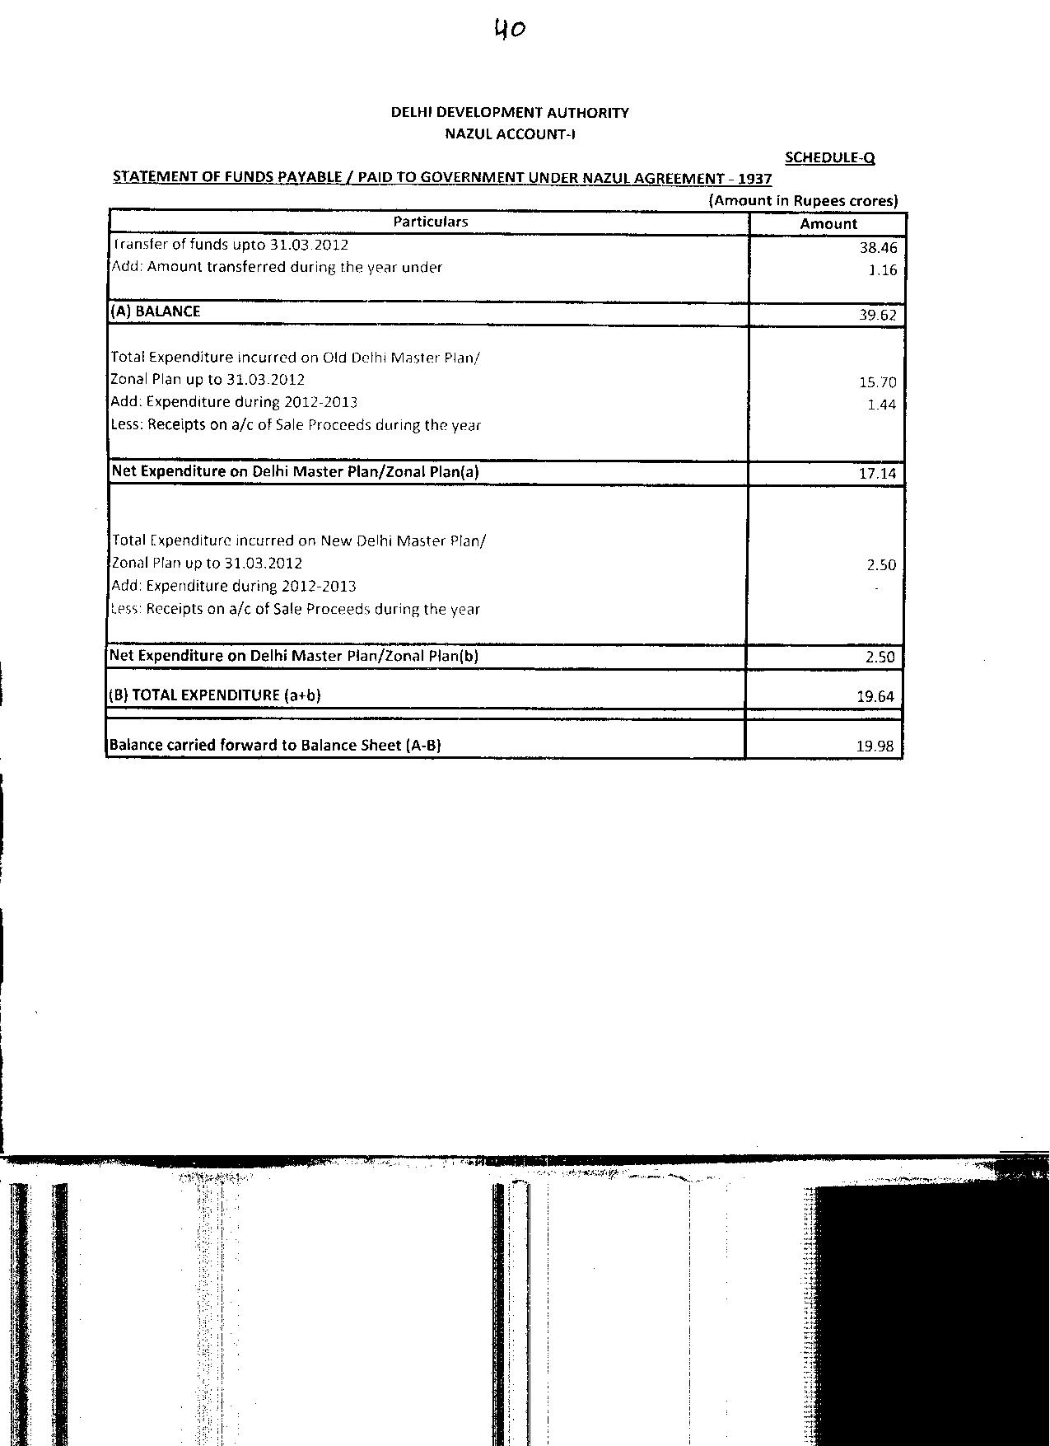
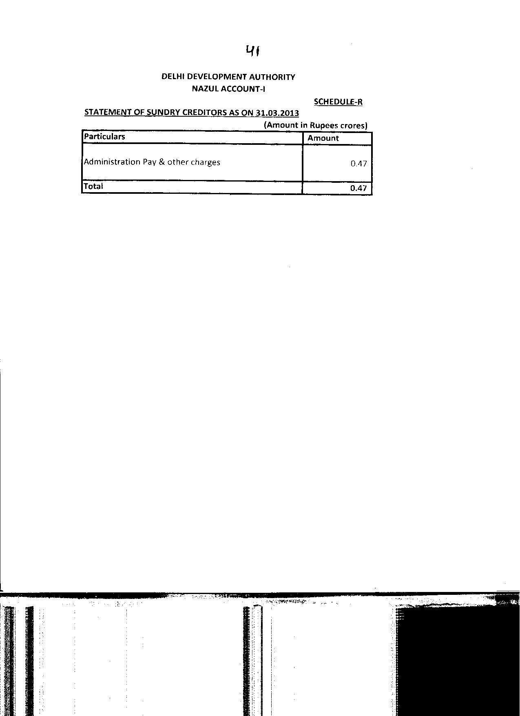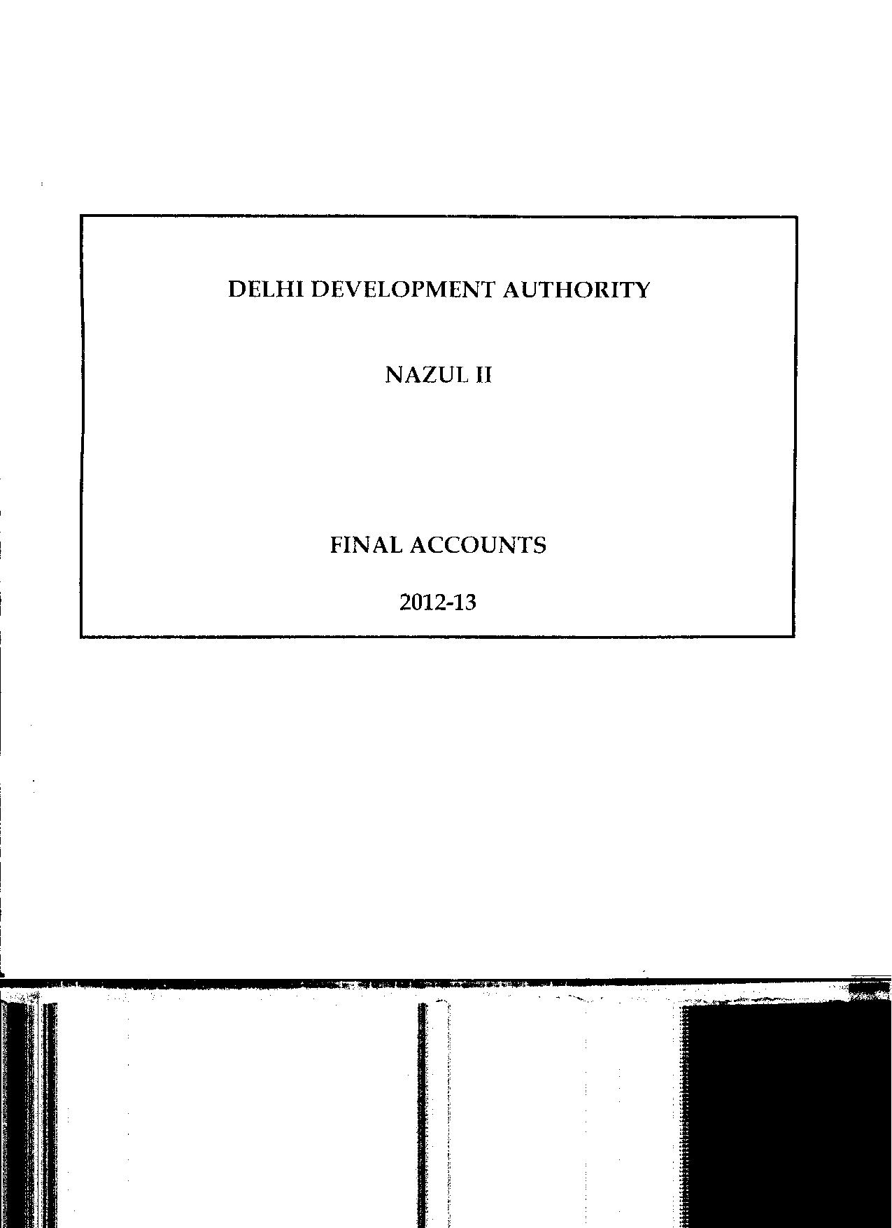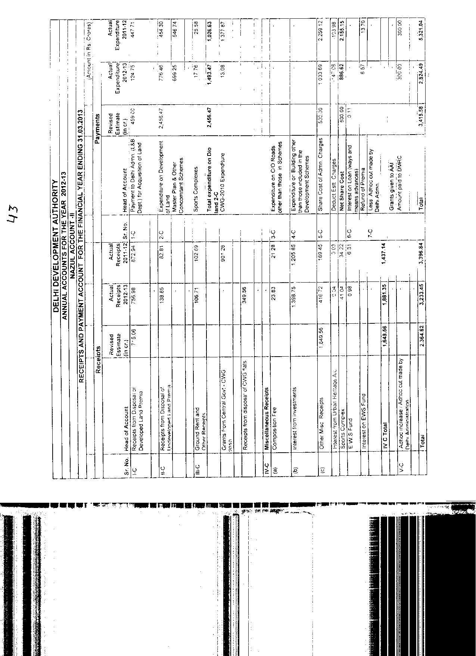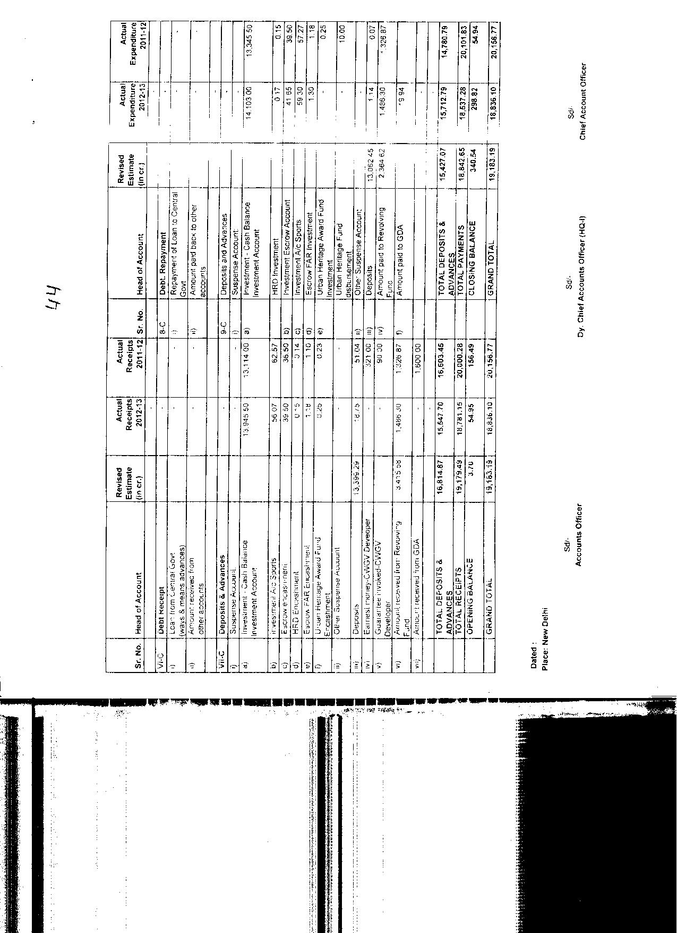

45

DELHI DEVELOPMENT AUTHORITY

FINAL ACCOUNTS

GRATUITY FUND TRUST
2012-13

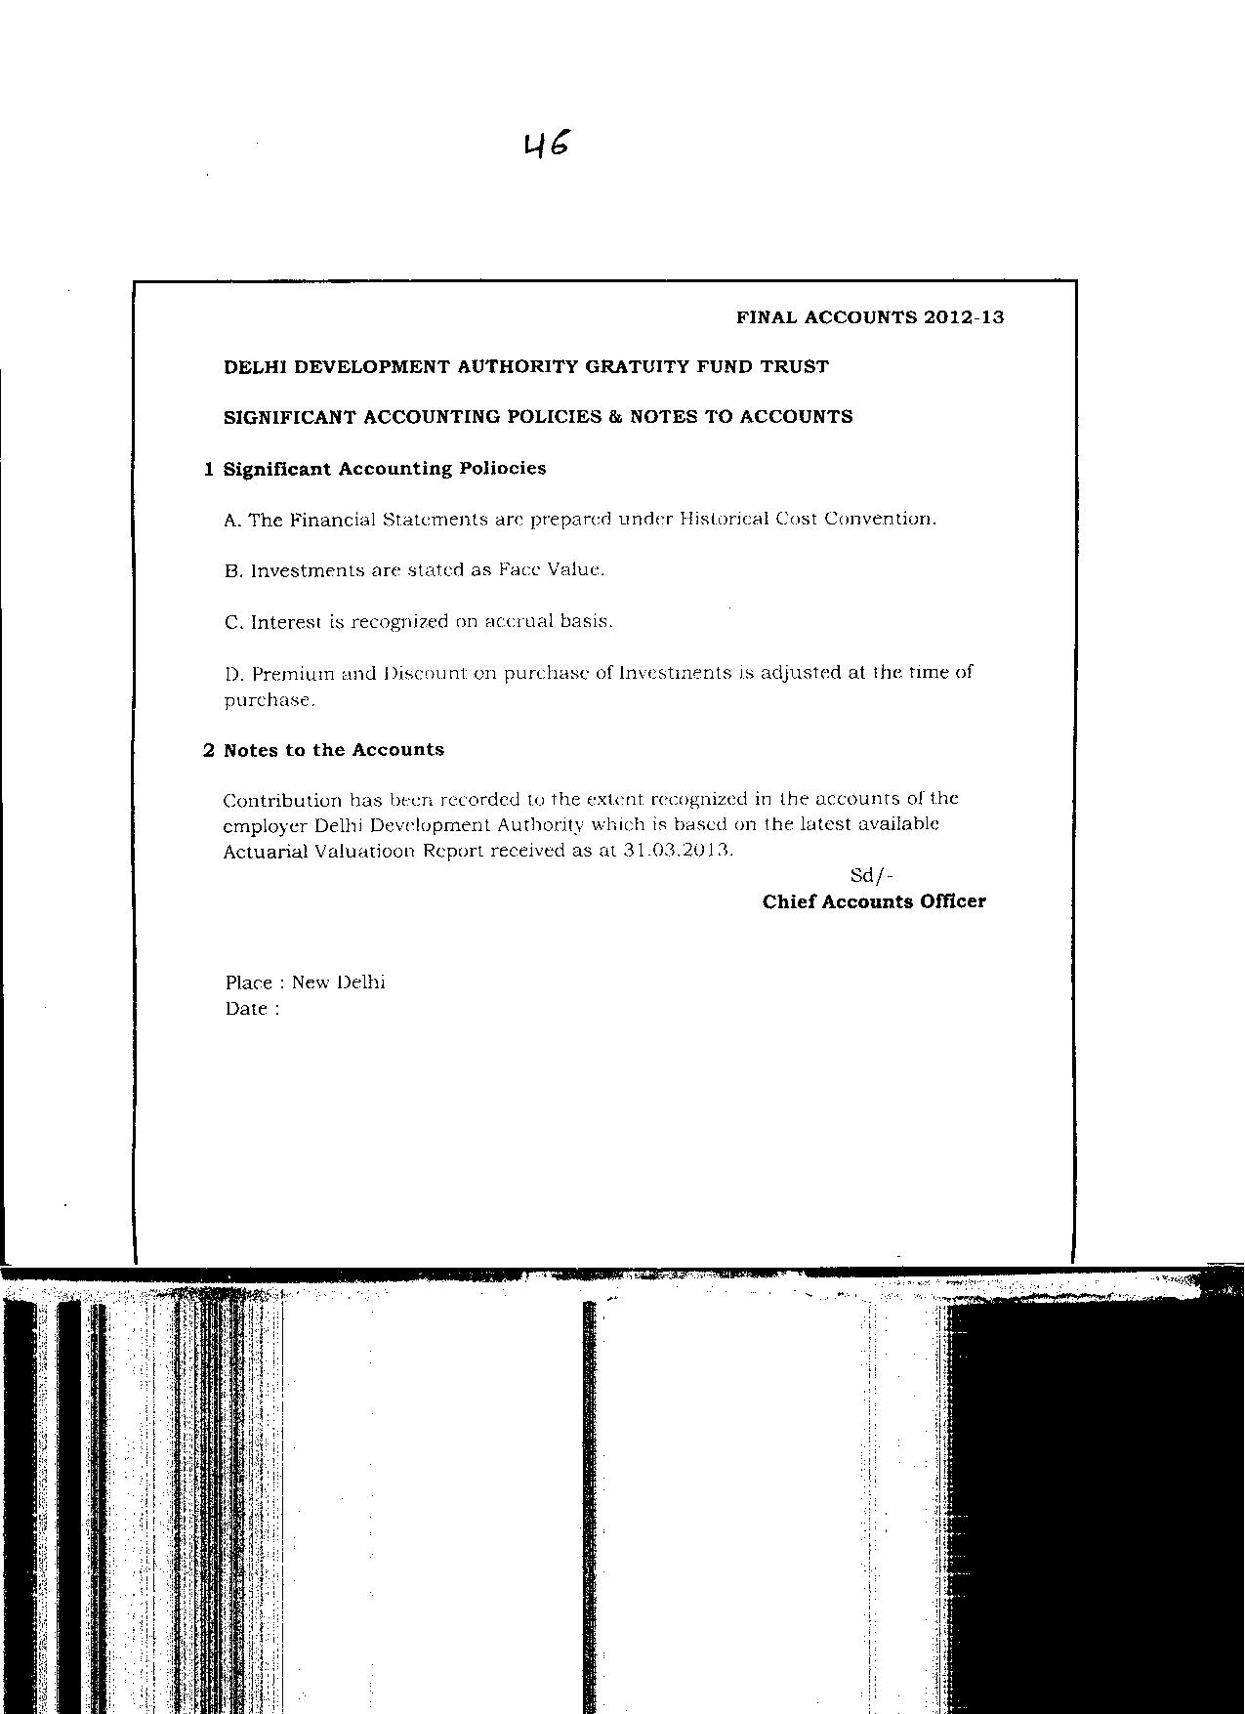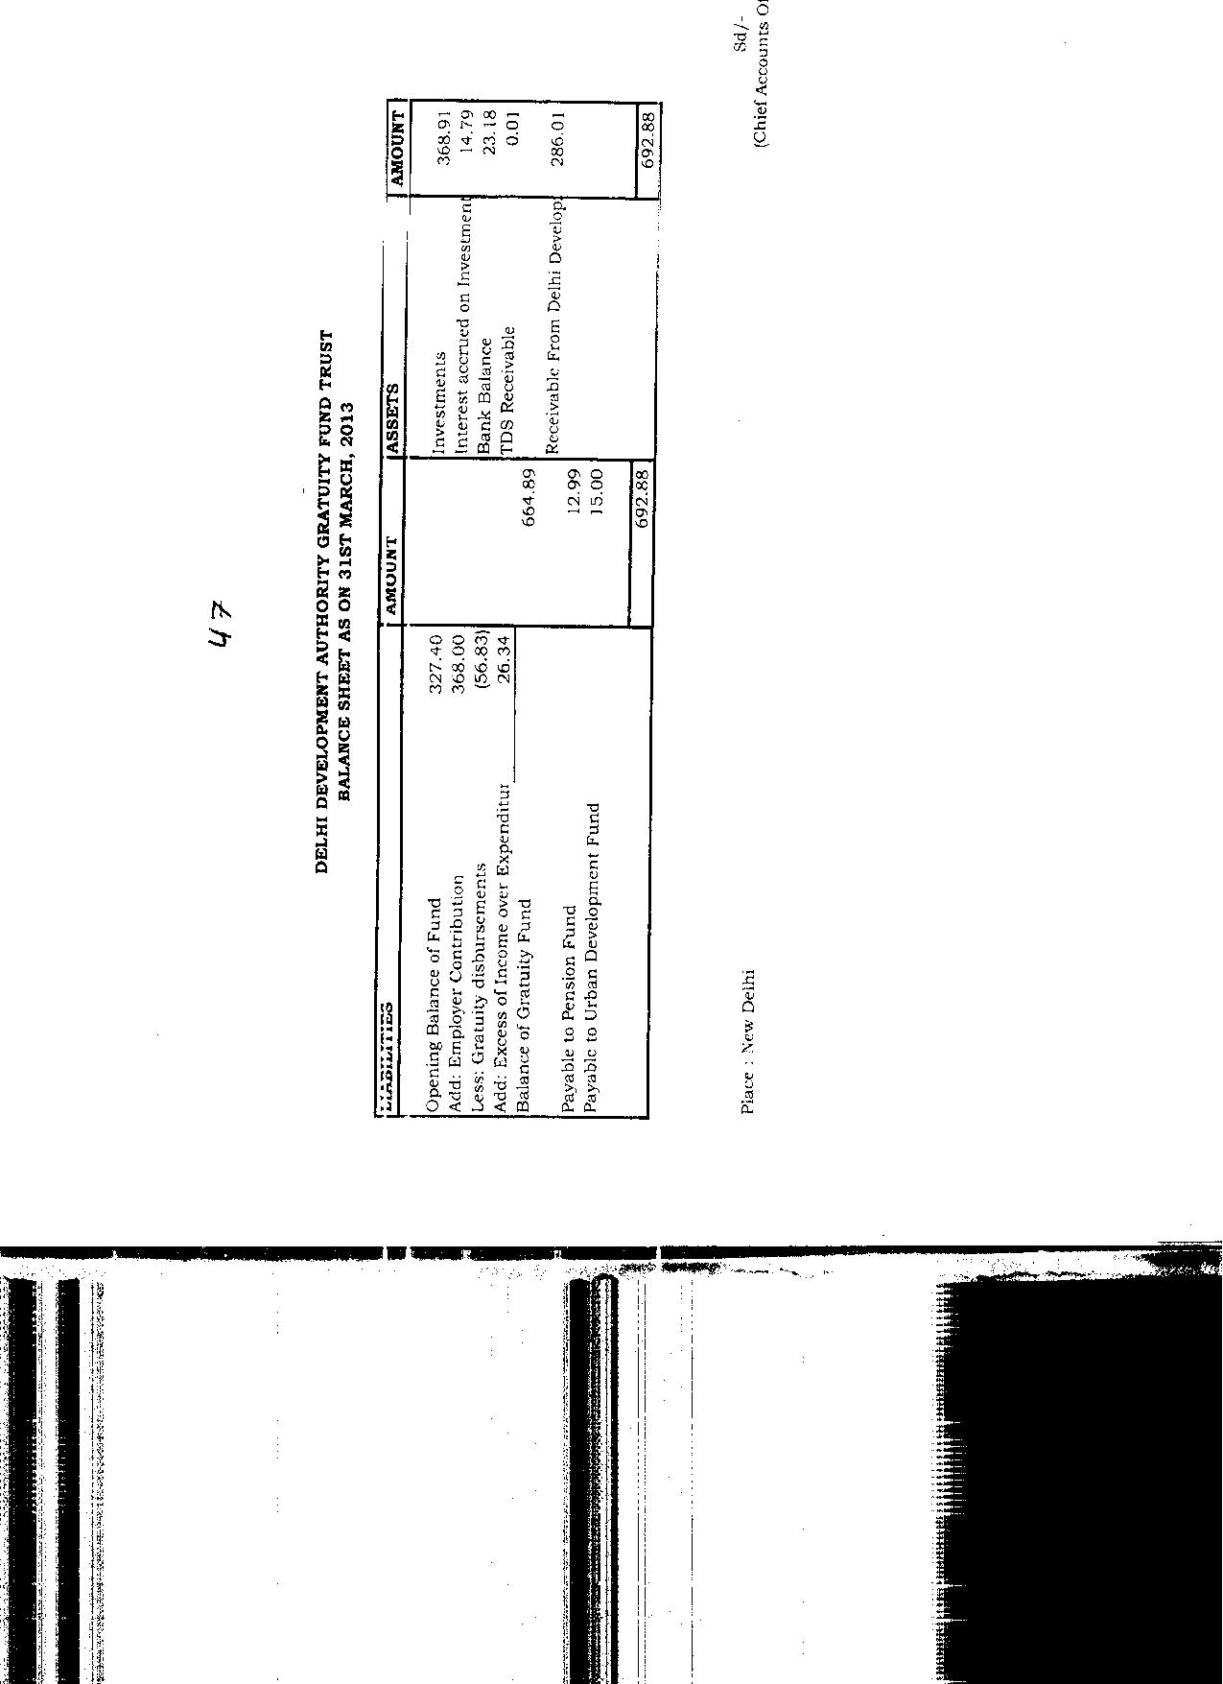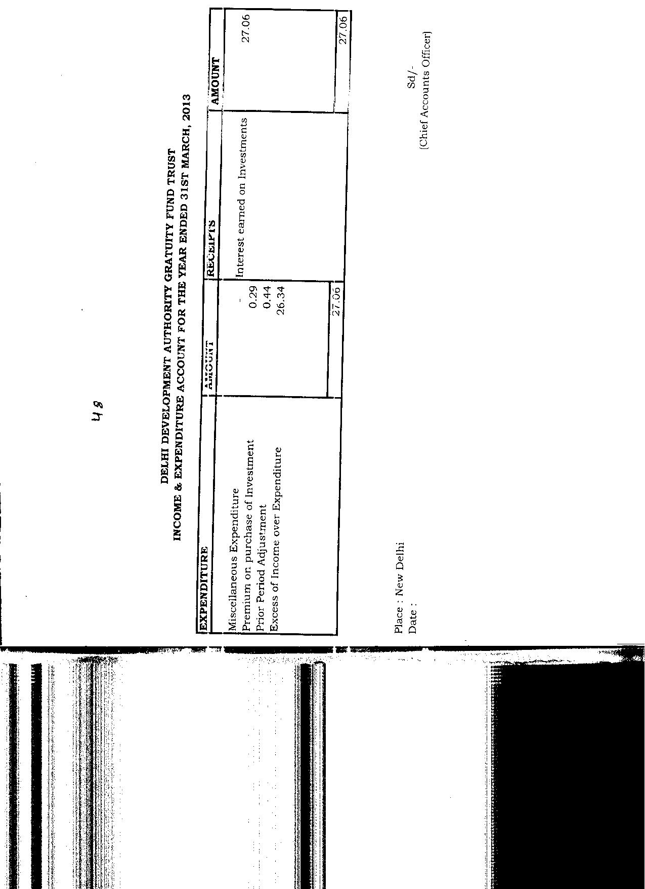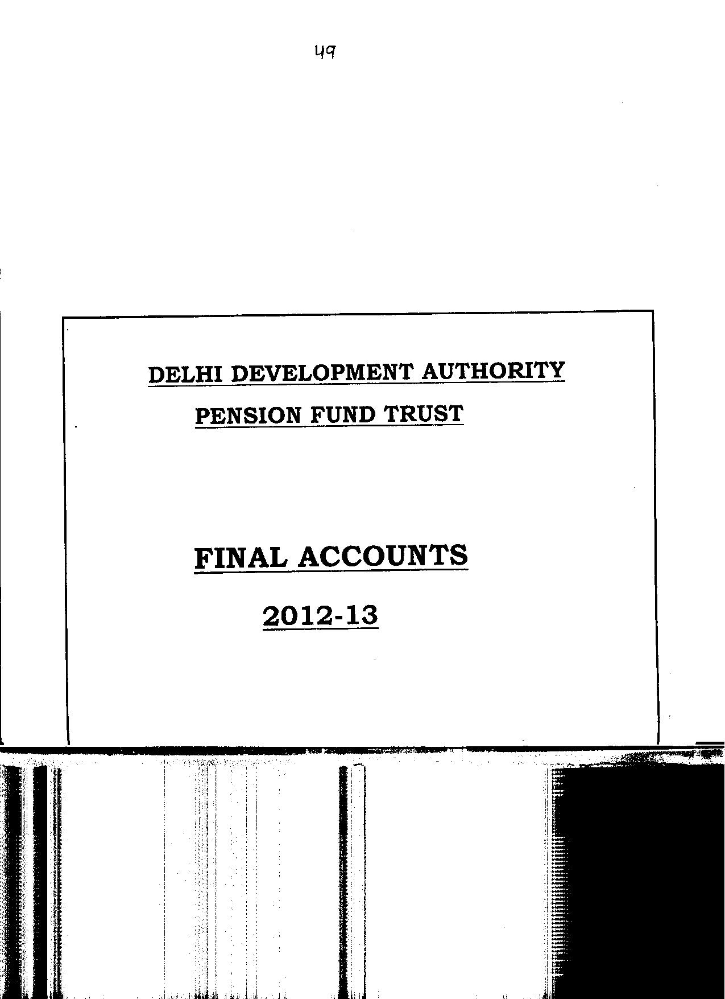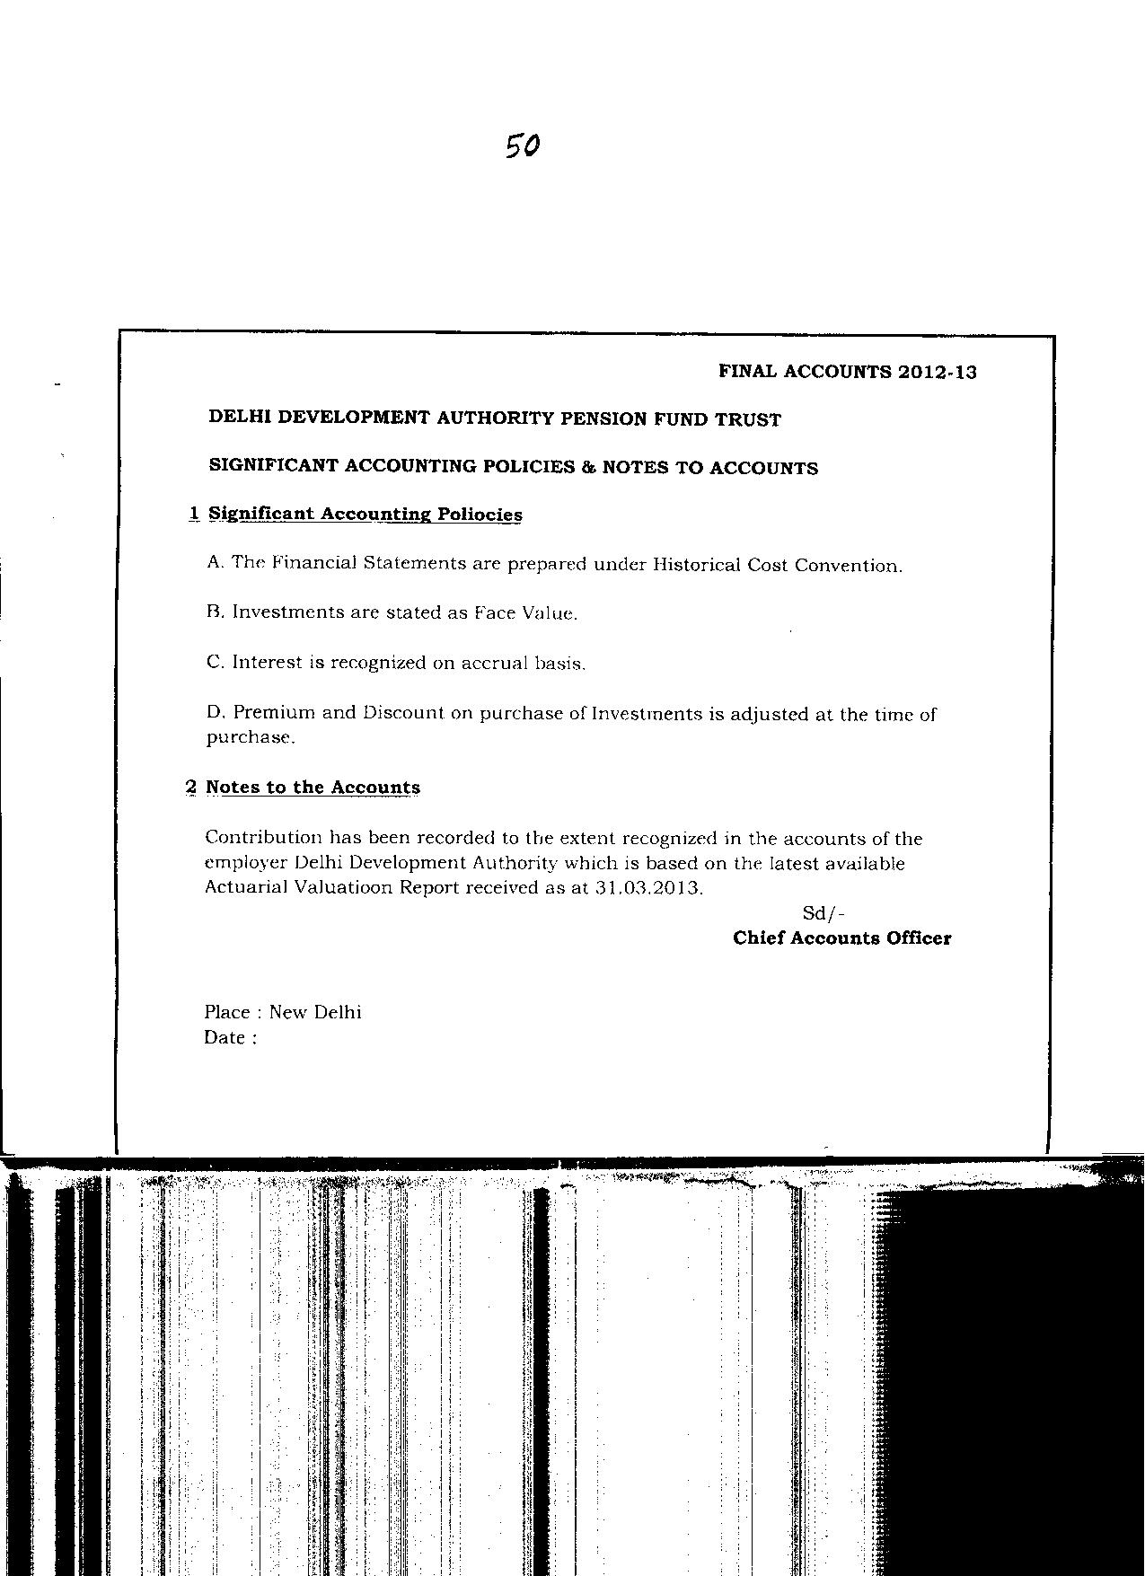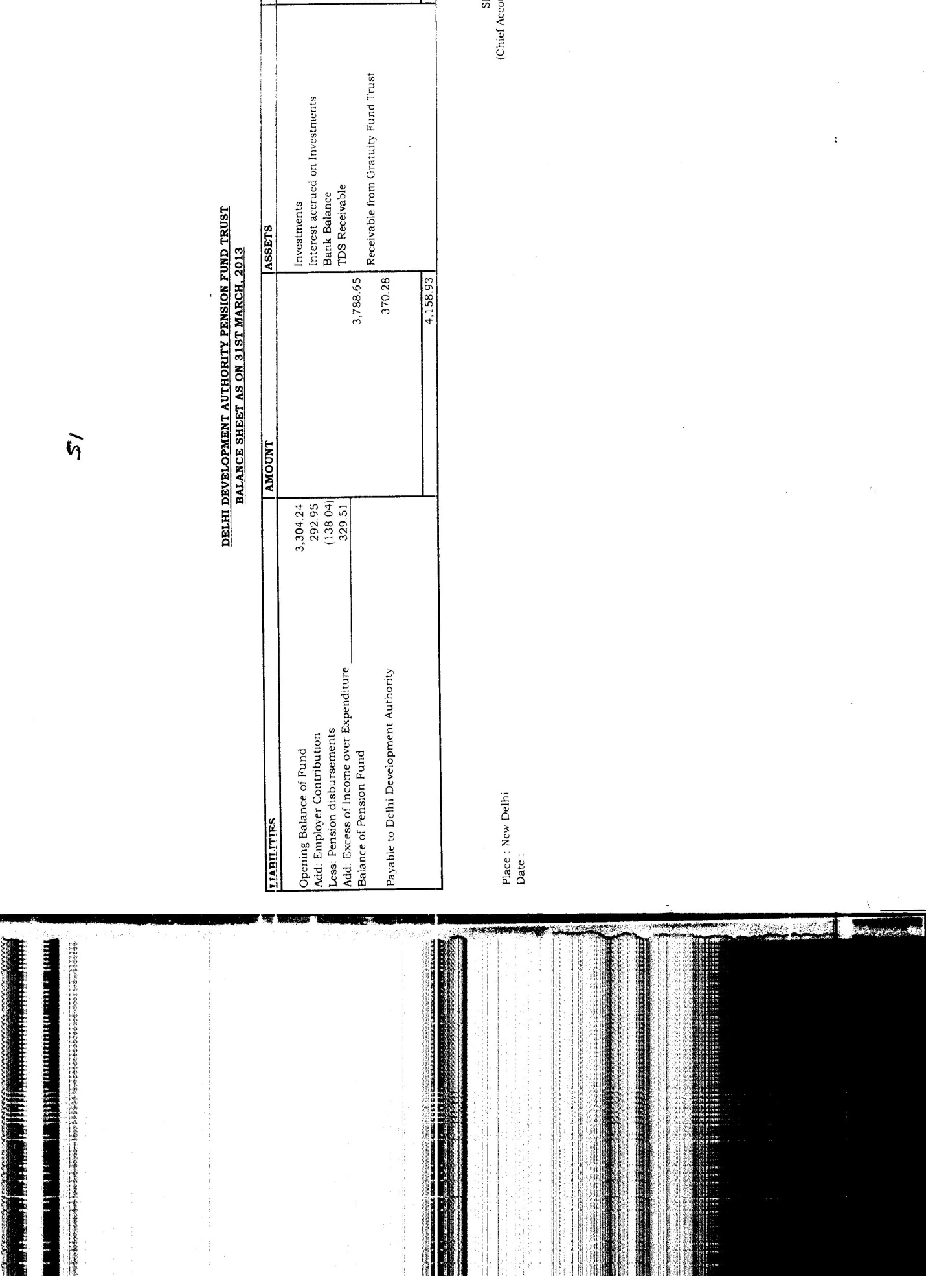
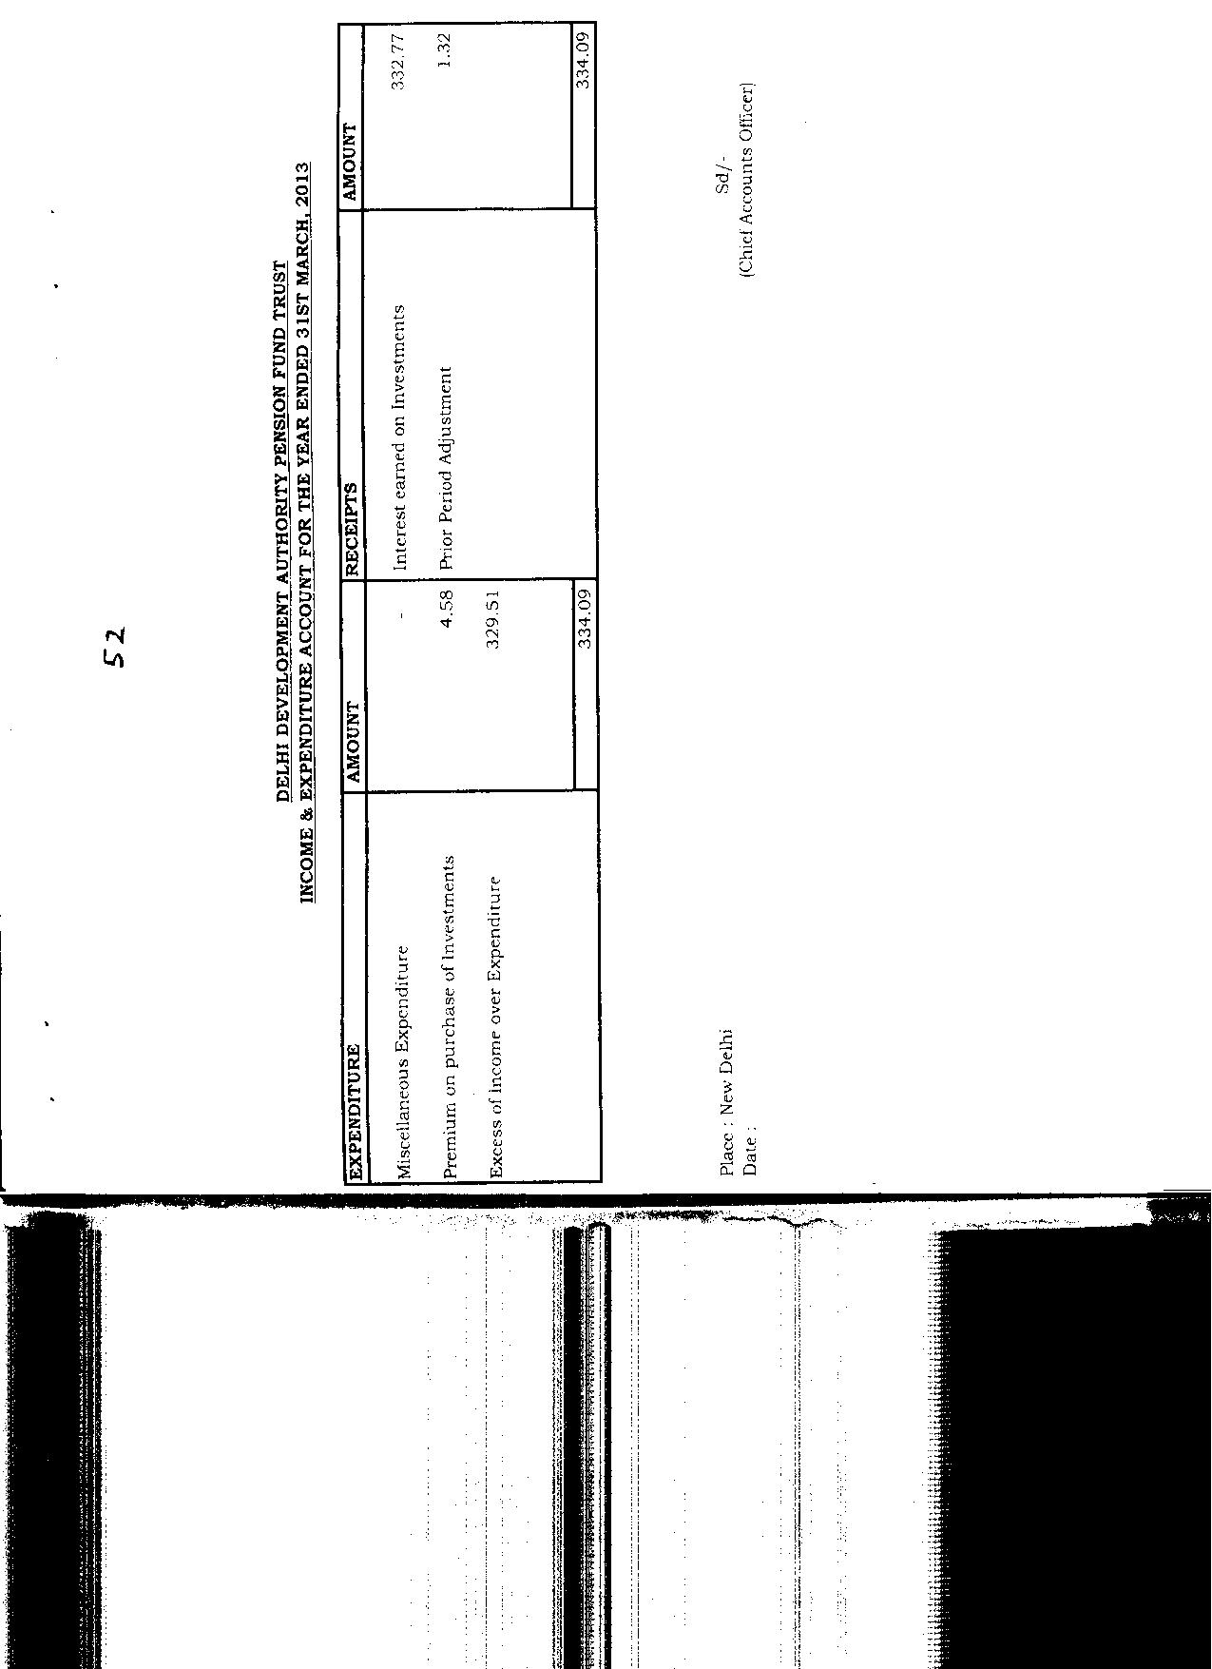
 | Separate Audit Report of CAG | Management Comments
 | A. BALANCE SHEET  1. Earmarked/ Endowment Funds (Schedule-B) ` 4066.59 crore  1.1 Urban Development Fund (UDF) ` 2850.99 crore  Delhi Development Authority has been maintaining Urban Development Fund (UDF) on behalf of Ministry of Urban Development (MoUD). The Fund was created in 1992-93 out of the sale proceeds from conversion of properties from lease hold to freehold basis. DDA on regular interval has been releasing funds as per the directions and approval of the Project Approval Committee. Audit observations with regard to UDF are as under:  - The closing balance of UDF has been shown as ` 2850.99 crore. However, as per Schedule –F ‘Investment of Earmarked/Endowment Funds’ the total amount of UDF funds worked out to ` 2434.24 crore. Thus there was a shortfall of UDF investment of ` 416.75 crore.  b) The above amount has been derived after debiting to UDF an amount of `15.00 crore paid towards the Gratuity Fund Trust account. As the expenditure did not pertain to the specific purposes for which the UDF funds are to be utilized, the same should not have been debited to the UDF. This resulted in understatement of UDF by `15.00 crore and overstatement of Reserves & Surplus to the same extent.  c) The Authority in its financial statements has shown payment of ` 34.60 crore from the UDF for the ‘Construction of Flyover’. It was, however, revealed from the UDF release files that an amount of ` 17.35 crore only was to be released from UDF and balance of ` 17.25 crore was to be released from GDA. This has resulted in understatement of UDF fund by `17.25 crore and understatement of GDA’s Expenditure by the same amount. | a) Audit has pointed out a shortfall of `416.75 Cr. in UDF at the end of the year 2012-13, out of which `280.82 Cr. already stands made good on 30.5.2013 and action for balance funds being taken separately which is likely to be completed in the current month.  (b) & (C) This error of mis-classification has already been rectified during the current year and shown to Audit also. No further action is required.
 | 1.2 VAMBAY `0.90 crore  A sum of ` 0.50 crore was received in April, 2002 under Valmiki Maleen Basti Awas Yojna as grant from the MoUD through HUDCO for shifting of Jhuggi dwellers. The grant was utilized and Utilisation Certificates were furnished during 2002-03. However, the amount of the grant and accumulated interest thereon aggregating to ` 0.90 crore was still lying in the Accounts which resulted in overstatement of Earmarked/Endowment Funds to the extent of ` 0.90 crore.  333 number of Commonwealth Games flats purchased by DDA from M/s Emaar MGF in May 2009 under a financing aid-package for a total consideration of ` 766.89 crore. The DDA has depicted the value of above flats as `1468.33 crore at which these flats were expected to be sold, whereas going by the concept of conservatism and the provisions of AS-2 'Inventory valuation' the flats should have been shown at cost i.e ` 766.89 crore or net realizable value, whichever is less. Thus, valuing the said inventory at a higher price has resulted in overstatement of current assets by ` 701.44 crore.  2. Current Liabilities & Provisions (Schedule-C) ` 2278.49 crore  Sundry Creditors- For Expenses ` 58.05 crore  The above did not include provision for work done in respect of construction of 457 HIG flats in Sector 18 B Dwarka against which 42nd running account bill of contractor amounting to ` 2.14 crore was pending as of 31.03.2013. Non-provisioning of this liability resulted in understatement of liabilities and Work-in Progress both by ` 2.14 crore. | Detailed reply has already been given to Audit while furnishing comments on SAR. However, funds lying in this Account will be transferred to appropriate Account i.e. BGDA during the current financial year.  Total liabilities shown in schedule ‘C’ of Annual Accounts is ` 2278.49 Cr. which is deficient to the extent of ` 2.14 Cr. only as pointed out by the Audit. This amount is hardly 0.09% of total liability which is insignificant considering the overall assets and liabilities of DDA. However, observations of the audit have been noted and instructions are being issued again to book the liability on more realistic basis.
 | 3. Current Assets, Loans and Advances (Schedule-G) `13025.14 crore  a) Inventories `4331.74 crore  Commonwealth Games Assets ` `1468.33 crore  The above assets represent 333 number of Commonwealth Games flats purchased by DDA from M/s Emaar MGF in May 2009 under a financing aid-package for a total consideration of `766.89 crore. The DDA has depicted the value of above flats as `1468.33 crore at which these flats were expected to be sold, whereas going by the concept of conservatism and the provisions of AS-2 'Inventory valuation' the flats should have been shown at cost i.e ` 766.89 crore or net realizable value, whichever is less. Thus, valuing the said inventory at a higher price has resulted in overstatement of current assets by ` 701.44 crore.  b) SundryDebtors `750.99 crore  Scrutiny of records of one of the divisions test checked in audit revealed that an amount of ` 1.78 crore relating to water charges was lying outstanding against the allottees as on 31.03.2013, but the same was not included in the list of debtors. This has resulted in understatement of sundry debtors and understatement of surplus to the extent of ` 1.78 crore.  c) Cash & Bank Balances `2572.90 crore  - The above included an amount of ` 0.35 crore which was lying un-reconciled for the period ranging from three to 16 years despite including the issue in the last Audit Report.  - The authority has shown receipts of ` 349.56 crore from the disposal of CWG flats booked under Nazul –II account. However, this amount also included ` 1.04 crore pertaining to earnest money deposits of rejected tenderers, which was not depicted in the accounts of Nazul-II, but refunded from the GDA account. The payment of ` 1.04 crore from GDA account resulted in understatement of reserve and surplus.  - The bank balance in Saving Bank Account amounting to ` 319.08 crore has been understated by ` 1.94 crore being the amount of stale cheques as on 31/03/2013. This has resulted in understatement of Bank balances as well as current liabilities to that extent. | Detailed reply to this para has already been given in para 11 of Draft SAR. Valuation of finished stock has been made as per accounting Policy 6 (c), which is in order and does not require any further action.  The overall position of outstanding water charge will be reconciled during the current financial year and will be updated in the Accounts accordingly. However, Audit Instructions are being circulated to all Accounts rendering units for compliance.  i) Out of ` 0.35 Cr. lying un-reconciled, a sum of ` 0.15 Cr. has been traced and will be set right in the current financial year. Efforts are being made to trace the old records for reconciling the balance of ` 0.20 Cr. and action will be taken accordingly.  ii) Necessary transfer entry for rectification of the error is being made and will be accounted for in the Accounts of current financial year. Compliance will be shown to the next audit party.  iii) Instructions have already been issued to all DDOs vide letter dated 05.8.2013 for cancellation of stale cheques. Observations of the audit have been noted for compliance and instructions are being again issued for the same.
 | B. INCOME AND EXPENDITURE ACCOUNT  Expenditure  - Establishment & Administration (Schedule-L) ` 324.37 crore  Ex-gratia ` 3.31 crore  The above did not include an amount of ` 3.85 crore payable towards Ex-gratia (Non-productivity Linked Bonus) to employees (calculated for Group ‘C’ and ‘D’ staff only as on 31.03.2013) for the year 2012-13 although the Centralised Accounting Units had provided the details of liabilities to the Authority. This has resulted in understatement of establishment & administration expenses and overstatement of reserve and surplus for the year 2012-13 by ` 3.85 crore. | This is not a contractual obligation. Consequent upon issuing the orders by the Govt. of India for payment of ex-gratia to the Central Govt. Employees, the Authority decided to pay it in the month of Nov. 2013. Hence, no liability arose on 31.3.2013.
 | Income  - Extra Ordinary Items `104.42 crore  As per Accounting Policy No.11 (A), the authority charges establishment and general administration cost in proportion to the expenditure outlay on schemes, projects or activities under General Development Account, Nazul-I and Nazul-II Accounts. The Authority has not deployed separate staff for Nazul-I and Nazul-II. As per the working sheets provided by the Authority, the cost ratio amongst the above three accounts i.e. GDA, Nazul-I and Nazul-II was 44.37%, 0.70% and 54.93% respectively for the year 2012-13. Review of Schedule – M revealed that `250.00 crore for Provision for Post Retirement Medical Scheme was shown in financial statements. Based on the above percentage, the share of GDA for contribution towards provision of Post Retirement Medical Scheme worked out to ` 110.92 crore. However, the Authority had booked ` 82.38 crore only towards the share of GDA. The short provision of ` 28.54 crore for Post Retirement Medical Scheme has resulted in understatement of expenditure as well as overstatement of surplus by same amount. | There is no financial impact of this para as only provision has been made for Post-Retirement Medical Scheme. Actual expenditure on PRMS will be taken into consideration for allocation during the current financial year.
 | - Increase in Stock & Works (Schedule-K) ` (-) 1122.43 crore  The above includes the stock of CWG-333 flats purchased by DDA from M/s Emaar MGF in May 2009 under a scheme called ‘Financing aid- package’ for a total consideration of ` 766.89 crore. The Authority has shown the opening balance and closing balance of such stock as ` 919.05 crore and `1468.33 crore respectively under Schedule –K. As such the Authority has booked income of `549.28 crore on account of increase in stock. It was, however, noticed from the records that the possession of the flats had not yet been handed over by the Project Developer to the Authority. Further, as the said flats had not been sold by the DDA upto 31.03.2013, hence routing of the same through Income & Expenditure account was irregular. Further, valuation of these 333 flats from ` 919.05 crore to ` 1468.33 crore itself was incorrect. This has resulted in the overstatement of income by ` 549.28 crore as well as the reserve and surplus of the Authority by the same amount. | Authority is valuing its finished stock of built up units according to Accounting Policy 6 (c), which is already explained under the head “Valuation of stock & stores,” statement of significant Accounting Policy. As the un-disposed flats represent the stock of the Authority, any change in value of stock would have to be reflected in the Income and expenditure Account since the Authority is following the accrual system of accounting.
 | C. SIGNIFICANT ACCOUNTING POLICIES  (i) Accounting Policy 6(c) regarding valuation of Finished Stock reads that "Built up Units comprising of Housing Stock are valued at standard cost at which expected to be sold, including land premium, less estimated cost of completion."  The above accounting policy is inconsistent with the provisions of Accounting Standaard-2 on 'Inventory Valuation' according to which the inventories should be valued at cost or net realisable value whichever is less.  (ii) As per the accounting policy 7(c) the rental income is recognized on the accrual basis whereas, as per accounting policy 7(d) ground rent income is accounted on cash basis. Since the Final Accounts is based on accrual basis, adoption of different policies in accounting of income is inconsistent with the Generally Accepted Accounting Principles and Practices. | DDA is a Charitable Institution registered in the year 2006 u/s 12A of the Income Tax Act 1961 and its sole objective is to develop Delhi in a planned manner and for providing low-cost and affordable housing opportunities to the public. The activities of DDA are not of commercial, industrial and business nature for earning profit as that of private businessman. Thus, AS 2 – ‘Valuation of Inventories’ is not applicable to the Authority. Therefore, Authority has adopted a compensatory pricing policy where the surplus in pricing of certain schemes like HIG/MIG compensates for the rebates and discounts allowed in other schemes like EWS which are built for the weaker sections of the society.  Rental income is certain to be received whereas in the case of ground rent, such income is to be received from general public at large and thus such income is uncertain in its receipt. Therefore, considering provisions of AS - 9 Rental incomes is recognized on accrual basis. Hoverer, ground rent is recognized on cash basis because of its uncertainty as per the Prudence Concept of Accounting. As such there is no question of adoption of different policies.
 | D. NOTES TO ACCOUNTS  As per disclosure made in Note No. 4, Income Tax assessment order dated 25-3-2013 for the assessment year 2010-11 has raised a demand of ` 171.67 crore from DDA. On the writ petition filed by DDA against the demand, the Delhi High Court has granted interim stay on payment of ` 7 crore which has been paid and for the balance amount no provision has been made by DDA.  The above Note was deficient to the extent that it did not disclose further Income Tax demand of ` 855.83 crore (`38.54 crore for assessment year 2003-04 and ` 817.29 crore for assessment years 2004-05 to 2009-10) raised by Income Tax Department.  Hence, contingent liability amounting to ` 855.83 crore on account of income tax should have been disclosed in the Notes to the Accounts.  E. GENERAL  - Investments: As per the information compiled by Audit, the Authority was having ` 25,970 crore in Bank fixed deposits, Government securities, Bonds and savings accounts. However, the authority did not disclose consolidated position of investments held by it.  ii) Total figure of GPF Investment and Bank balance (Schedule-F) works out to ` 1189.71 crore against the liability of ` 1214.31 crore (Schedule-B). Thus, there was a short fall of GPF Investment to the extent of ` 24.60 crore.  iii) DDA incurred net excess expenditure to the extent of ` 88.41crore (Schedule-G) as on 31.03.2013 against Deposit Works which includes excess expenditure to the extent of ` 3.54 crore for the year 2012-13. However, Client-Department wise details of Deposit Works amounting to ` 88.41 crore as on 31/03/2013 were not available with DDA. In the absence of the same, the recoverable amount against Deposit Works shown in the Accounts could not be vouched safe in Audit.  iv) The Authority has not created a provision of stores items like scrapped tee section, pipes and damaged shutter in Stores, which are no longer required. This has resulted in overstatement of stores valuing ` 7.75 crore. This was also pointed out last year through Management Letter but no action has been taken so far.  v) Reconciliation of Sundry Debtors: The DDA has shown ` 750.99 crore as Sundry Debtors in the financial statements of General Development Account as on 31 March 2013. There is no system of providing adequate provision for bad and doubtful debts. Further, the Authority has not been maintaining party-wise and age-wise breakup of debtors. Also, there is no proper system of monitoring of recovery of installments in respect of hire-purchase flats. As such the Sundry Debtors valuing ` 750.99 crore in the financial statements for the year ending March 2013 could not be vouched safe in Audit. | The demand for these years was received by the Authority on 12.07.2013. Annual Accounts of the Authority were finalized prior to such receipt of notice except signing of the Final Accounts on 23.07.2013 which was a mere formality. However, same will be considered while preparing the Annual accounts of the Authority 2013-14.  i) Investment made in different funds has been shown under the earmarked prescribed schedule meant for this purpose as per the Common format of Accounts.  ii) As the shortfall of Rs.24.60 Cr. has already been made good in the month of Aug. 2013 i.e. before completion of Audit, no further action is required.  - iii) This is the case of mis-classification of receipts which is being reconciled and correct position will be reflected in the current year’s Accounts.  iv. Stores are no longer in use and instructions are being issued to dispose of these scrapped items. Instructions of the audit have also been noted for compliance.  v) Debtors of the Authority are of General Public and it is not practicable to get confirmation of balance from them. Old allottee’s Accounts are pending for reconciliation, whereas allottee’s Accounts of New Scheme are reconciled. Disclosure in this regard has already been given in note 15 in the Note to Accounts.
 | F. NAZUL-II ACCOUNTS  In respect of Nazul-II Accounts the Authority was preparing Receipts and Payments Accounts only, as a result of which the position of total assets and liabilities of Nazul-II were not depicted in the financial statements as may be seen from a few of the cases noticed in audit as under:  i) An amount of `31.89 crore (54.93% of total liabilities of ` 58.05 crore) allocated by General Development Account towards administrative and establishment expenses for Nazul-II remained unaccounted in the financial statements for the period ended 31 March 2013.  ii) An amount of ` 1500.00 crore was sanctioned during 2011-12 by the MoUD as grant from Nazul-II to Delhi Metro Rail Corporation. Out of ` 1500.00 crore DDA has released ` 600 crore so far (` 300.00 crore each in 2011-12 and 2012-13) to DMRC. However, the liability of balance amount of ` 900.00 crore was not depicted in the accounts.  iii) Accounts did not depict assets valuing ` 1454.79 crore, in terms of 304 flats, which were available for sale on the Balance Sheet date.  iv) Nazul-II had investments amounting to ` 13903.00 crore as on 31.03.2013. Although all investment transactions are carried through the Receipts and Payments Account made for Nazul-II, in the absence of the Balance Sheet for Nazul-II, the investments position as on 31.03.2013 was not reflected appropriately.  G. GRANT –IN-AID  During the financial year 2012-13, no grant- in- aid was received by the Authority from the Central Government. | It is submitted that Nazul II Account belongs to Government and DDA is merely acting as a custodian and hence does not prepare the Balance Sheet of Nazul II. Details of monthly receipts & payments are duly sent regularly to the concerned department.  i) As no balance sheet is required to be prepared in respect of Nazul A/C –II as per the DDA Budget & Accounts Rule 1982, so liability relating to Nazul A/C –II could not be taken in the Balance Sheet.  ii. As already clarified during the Audit that payment of Rs.900.00 Cr. is to be made in subsequent years, so the question of creating liability in the Accounts of 2012-13 does not arise.  iii) As no balance sheet is required to be prepared in respect of Nazul A/C –II as per the DDA Budget & Accounts Rule 1982, so liability relating to Nazul A/C –II could not be taken in the Balance Sheet.  - iv) Investment made under Nazul A/c –II have already been reflected clearly in the Receipt & Payment Account of Nazul A/C –II at page - 39 of the financial statement.  Informatory para, hence no comments.
 | Deficiencies noticed in Management letter dated 09.1.2014. | Remedial/corrective action is being taken separately on the issues raised in the management letter of the Audit.

