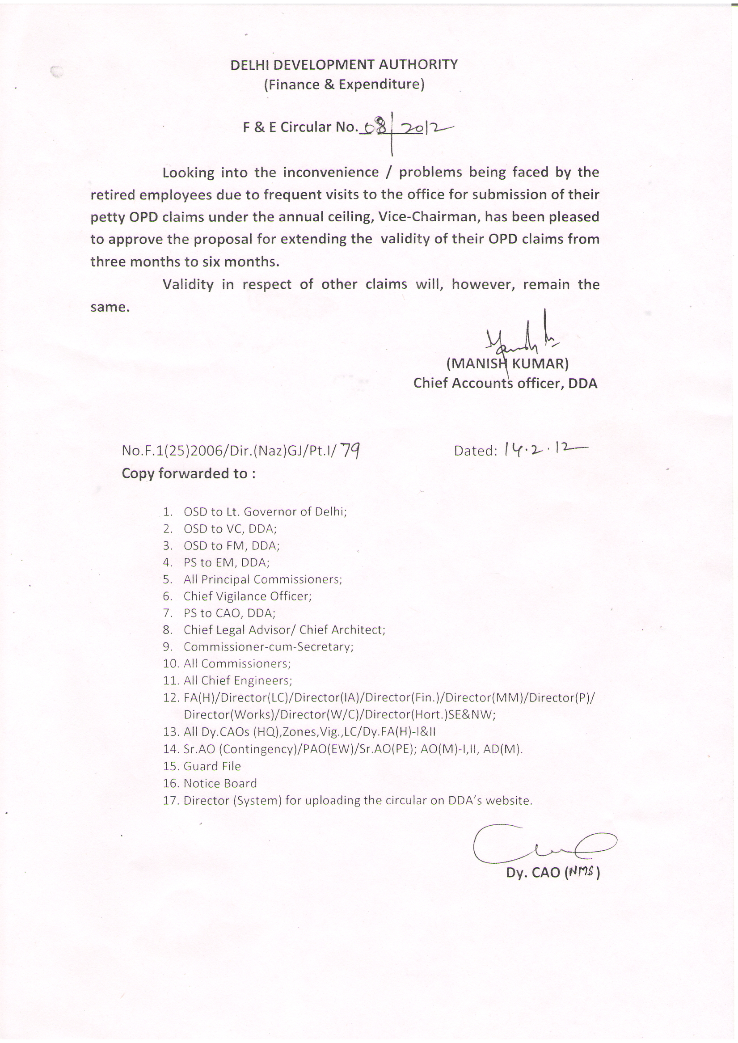
F&E CIRCULAR NO. 08/2012 DT 14.02.12 – REGARDING EXTENDING THE VALIDITY PERIOD OF OPD CLAIMS OF PENSIONERS

